Name__________________________________________________

Arson

Due Date:

Guide ___________________
Review ___________________
Critical Thinking ___________________
Concept Map ___________________
Crossword ___________________

Arson Investigation
Fire
Fire Triangle
Flash Point
Point of Origin
Burn patterns
Accelerants
Arson
Char Patterns
V-Patterns
Heat Shadows
Chimney Effect
Name_______________________________________________ Score_________
Arson Investigation Review
Fire | Point of Origin | Arson | Heat Shadows
Fire Triangle | Burn patterns | Char Patterns | Chimney Effect
Flash Point | Accelerants | V-Patterns

- A ________________________________________________ is created by very hot fires that burn very quickly and move fast along its path.
- _________________________________________ is a fire started deliberately.
- Noticeable patterns created by the fire as it burns are ________________________________
_________________________________________________.
- _______________________________________________________ occur when heavy furniture shields part of a wall.
- ________________________________________________________ are produced when a substance undergoes rapid oxidation involving heat and light.
- The ______________________________________________________ shows the three elements needed to produce and sustain a fire.
- __________________________________________ are substances that speed up the burning process.
- The _______________________________________________________ is created when superheated gases rise upward and form a fireball.
- The __________________________________________________ is the location where the fire started.
- _____________________________________________________________ is the lowest temperature to which a substance must be heated in order for the substance to give off vapors which will burn when exposed to a flame or ignition source.
- The _____________________________________________________ is the pattern created when fire burns up.

- _____Narrow v-shape a. slow burning fire
- _____wide v-shape b. pool or origin
- _____u-shape c. hotter than normal fire

- _____origin of a fire a. color of smoke
- _____temperature of the flames b. chimney effect
- _____type of material burning c. color of flames
Determine whether the fire is accidental (A) or on purpose (P).
- _____inverted v-patterns
- _____children playing with matches
- _____two or more points of origin
- _____heating system
- _____locked windows, blocked doors

Determine whether the statement is true (T) or false (F).
- _____v-patterns determine the type of accelerant used.
- _____Fire will not burn until the fuel reaches a high enough temperature.
- _____Heat shadows help determine the origin of a fire.
- _____Arson investigators work from the most damaged area to the least damaged area.
- _____The location where a fires starts is the flash point.

- The fire triangle is

  - Point of origin, burn patterns and accelerants
  - Heat, fuel and oxygen
  - Burn patterns, char patterns and v-patterns
  - Heat, flashpoint and accelerants

- A dark layer of soot on a window may indicate
  - A slow fire
  - A hot fire
  - A cool fire
  - The chimney effect

- Char patterns help investigators determine
  - The location of a fire
  - The path of a fire
  - How fast the fire was moving
  - All of the above

- Fire investigators
  - Interview witnesses
  - Determine the point of origin
  - Collect evidence such as accelerants
  - All of the above

- Heat shadows help investigators determine
  - Type of accelerant used
  - Point of origin
  - How fast the fire moved
  - How hot the fire burned

- The origin of a fire directly below a hole in the ceiling is the
  - V-pattern
  - Char pattern
  - Chimney effect
  - Heat shadow

- Fires started in multiple places can be determined by looking at
  - Trailers
  - Heat shadows
  - U-patterns
  - Inverted v-patterns

- What is the percentage of oxygen needed for fire to burn?
  - 70%
  - 21%
  - 16%
  - 10%

- A pool of accelerant can be determined by looking at
  - Narrow v-patterns
  - Wide v-patterns
  - U-shaped patterns
  - Heat shadows

- During a fire light bulbs
  - Melt toward the fire.
  - Melt away from the fire.
  - Explode.
  - Nothing happens because glass does not burn.

Name______________________________________________________ Score________
Arson Critical Thinking
- What is necessary for a fire to burn?

- What is the difference between the point of origin and the flash point?

- What are three indications that a fire is not accidental?

- What are three motives a person might have to commit arson?

- Why isn’t children playing with matches considered arson?

Name__________________________________________________ Score________
Arson Concept Map
Use the following terms to create a concept map: burn pattern, slow burning, wide v-shape, u-shape, pool of origin, hotter than normal, narrow v-shape.

Use the following terms to create a concept map: origin of fire, fire, color of flames, type of material, chimney effect, color of smoke, temperature.

- What are accelerants?

- What are char patterns?

- What can investigators learn from glass?

- What sort of information do investigators look for after a fire?

- What are heat shadows?

Arson Investigation
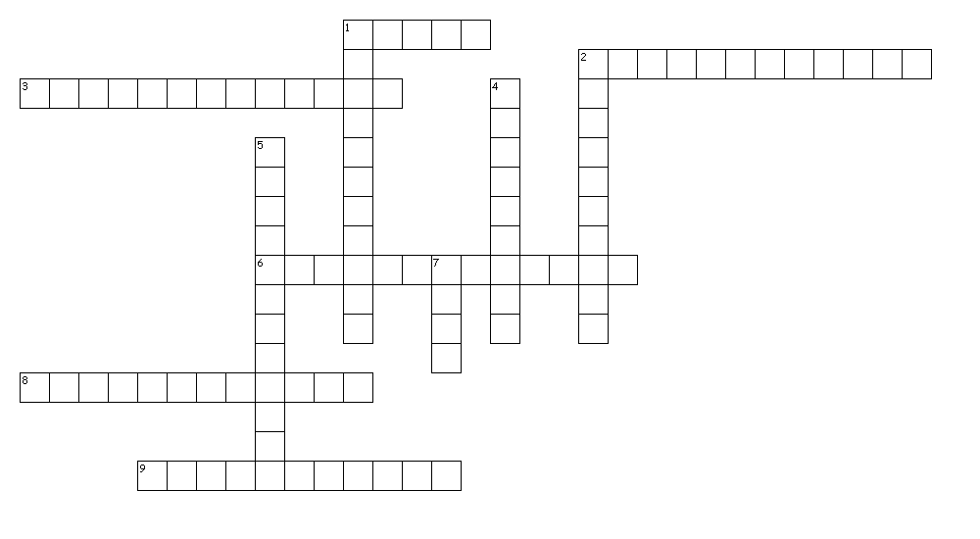
Across
1. fire started deliberately
2. Shows the three elements needed to produce and sustain a fire
3. superheated gases rise upward and form a fireball
6. the location where the fire started
8. Noticeable patterns created by the fire as it burns
9. Occur when heavy furniture shields part of a wall
Down
1. substances that speed up the burning process
2. The lowest temperature to which a substance must be heated in order for the substance to give off vapors which will burn when exposed to a flame or ignition source
4. the pattern created when fire burns up
5. Created by very hot fires that burn very quickly and move fast along its path
7. Produced when a substance undergoes rapid oxidation involving heat and light

H | F | R | H | N | H | H | P | K | P | B | V | N | J | X | V | L | Y | D | K
E | Q | I | K | U | A | L | K | X | F | J | I | K | O | N | W | Y | K | Z | R
B | M | P | R | Q | Y | T | L | J | I | G | C | Z | F | T | K | S | N | O | X
W | I | K | W | E | R | S | C | H | I | M | N | E | Y | E | F | F | E | C | T
X | Z | O | N | W | T | Z | W | R | G | S | P | L | B | G | S | R | Z | G | U
I | U | W | H | C | Y | R | O | O | N | E | E | E | U | U | V | Y | C | J | H
H | A | B | W | V | Y | F | I | R | D | V | H | C | R | N | F | I | F | V | L
L | M | K | R | B | O | Y | E | A | C | A | H | M | N | E | J | Z | T | Z | O
U | J | N | A | T | L | T | K | K | N | A | H | L | P | E | L | V | U | M | A
X | J | O | N | P | T | B | M | X | R | G | Q | S | A | V | Y | K | T | Y | T
E | D | I | O | A | P | G | C | P | I | V | L | N | T | Q | Z | L | F | J | N
R | O | X | P | J | K | E | A | S | D | R | U | E | T | A | V | E | P | I | I
P | N | V | H | X | P | T | H | S | T | N | A | R | E | L | E | C | C | A | O
N | X | V | F | G | T | S | P | J | R | C | W | S | R | M | D | H | H | A | P
Z | O | V | G | E | Y | Z | Q | W | M | S | Y | T | N | J | L | R | G | I | H
O | R | I | R | Y | L | X | C | I | E | G | T | T | S | I | Y | H | M | G | S
E | B | N | F | E | H | V | C | H | O | R | Z | Q | T | P | V | M | J | H | A
L | S | U | A | I | X | D | M | C | H | C | I | S | I | S | U | T | H | R | L
G | I | Z | Q | M | R | K | P | V | K | Q | B | B | Y | Q | T | E | E | F | F
A | R | S | O | N | E | E | L | A | E | D | G | R | B | A | H | V | J | K | Q

ACCELERANTS | ARSON | BURNPATTERNS
CHARPATTERNS | CHIMNEYEFFECT | FIRE
FIRETRIANGLE | FLASHPOINT | HEATSHADOWS
POINTOFORIGIN | VPATTERNS
