Forensics Lesson 10
Arson Investigation

Quiz Date:

Vocabulary
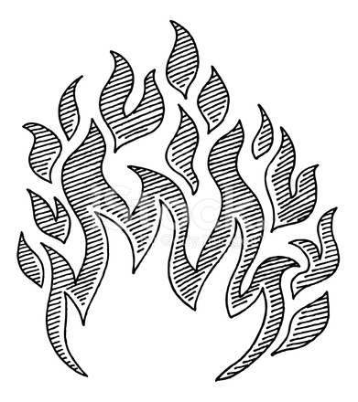

Fire Investigation Terms
- Fire - Produced when a substance undergoes rapid oxidation involving heat and light.
- Fire Triangle – Shows the three elements needed to produce and sustain a fire.
- Flash Point – The lowest temperature to which a substance must be heated in order for the substance to give off vapors which will burn when exposed to a flame or ignition source.
- Point of Origin – The location where the fire started.
- Burn patterns –Noticeable patterns created by the fire as it burns.
- Accelerants – Substances, such as gasoline, paint thinner, and alcohol, that accelerate the burning process.
- Arson – A fire started deliberately
Fuel + Oxygen + Heat = Fire
- The FIRE TRIANGLE represents the three elements
needed for fire to occur: heat, fuel, and oxygen.
- Fuel can be any combustible material in any state of matter - solid, liquid, or gas. Most solids and liquids become a vapor or gas before they will burn.
- The air we breathe is about 21% oxygen. Fire requires an atmosphere with at least 16% oxygen.
- Heat is the energy necessary to increase the temperature of the fuel to a point where sufficient vapors are given off for ignition to occur.
Fire Clues
- Point of Origin – Burn patterns and other damage can help determine the point of origin, or the location where the fire started.
- Char Patterns – Created by very hot fires that burn very quickly and move fast along its path, so that there can be sharp lines between what is burned and what isn't.
  - A char pattern on a door would help an investigator determine which side of the door the fire was on.
  - A char pattern on the floor would help investigators determine the use of an accelerant and its path.
- V-Patterns - Fire burns up, in a V-shaped pattern, so a fire that starts at an outlet against a wall leaves a char pattern that points to the origin.
  - A very narrow V-shape might indicate a fire that was hotter than normal, such as one helped along by an accelerant.
  - A wide V-shape might indicate a fire that was slow burning.
  - A U-shape could indicate that there was a "pool of origin" rather than a point of origin, such as might be caused by, say, a puddle of gasoline.
- Heat Shadows - Occur when heavy furniture shields part of a wall; can help determine the origin point.
- Glass - Glass fragments, windows, and light bulbs can provide clues to a fire.
  - Light bulbs tend to melt toward the heat source, so the "direction of melt" can indicate the direction of the fire.
  - The shattered or cracked glass of the windows can provide indications as to how a fire burned.
  - A dark soot layer on the glass could indicate a slow, smoldering fire.
  - Clear glass with an abnormal pattern of cracking could imply a very hot fire, possibly due to an accelerant.
- Chimney Effect - Since fire burns upwards, there can be a "chimney effect" where the fire ignites at a point, the superheated gases rise upward and form a fireball, which continues straight up to burn a hole in the ceiling.
- If the roof is not entirely burnt, and the fire investigator finds such a hole, the origin of the fire could be directly underneath.
- Color of smoke – Determine what type material was burning
- Color of flames – Indicates at what temperature the fire was burning.
Fire Investigation Basics
- Work from the least damaged areas to the most heavily damaged areas.
- Document with notes, photographs, and videos.
- Collect evidence (accelerant samples, fire items, and other crime scene evidence.)
- Interview witnesses
- Determine the point of origin.
- Determine the heat source(s).
- Hypothesize the reasons for the fire.

Accident or Arson?
- Accidental Nature
  - Heating System
  - Electrical appliances
  - Lightning
  - Children playing with matches
  - Smoking
- Non-Accident
  - Odors – Gas, kerosene, or other accelerants
  - Furnishing – Removal of personal objects and valuables
  - Clothing – Check debris for buttons, zippers, etc
  - Locked windows, blocked doors
  - Two or more points of origin
  - Look for inverted v-patterns (can be a sign that an accelerant was used)
  - Floors charred –Can indicate use of an accelerant
  - Trailers that lead the fire from one place to another
Arson Facts in America
- According to the FBI Crime Index, juvenile and adult arson cause an annual average of 560,000 fires, 750 deaths, 3,700 injuries, and $1.5 billion in property loss.
- 55% of all arson arrests in the US are children under 18.

What are Common Motives for Arson?
- Crime concealment: To conceal another crime such as murder, burglary, or vehicle.
- Revenge or spite: To get back at someone for a perceived injustice.
- Monetary Gain: Arson-for-Profit fires are set to burn a building, vehicle, or some other object in order to gain profit from the fire. The profit may come in several forms; from insurance coverage on the property, or from putting a competitor out of business.
- Malicious Vandalism: Fire set to someone’s property, just to destroy it. Malicious vandalism fires account for the largest percentage of arson fires. These fires are frequently set by juveniles.
- Mentally Disturbed: Some persons have been found to have an irresistible impulse to set fires.

