Name__________________________________________________

Blood Evidence

Due Date:

Guide ___________________
Review ___________________
Critical Thinking ___________________
Concept Map ___________________
Crossword ___________________

Blood Basics Guide
erythrocytes
leukocytes
plasma
thrombocytes
agglutinogens
spatter
Origin/Source
Angle of Impact
Parent Drop
Satellite Spatters
Spines
Passive Bloodstains
Projected Bloodstains
Contact Bloodstains
wipe pattern
swipe pattern

Name______________________________________________ Score________
Blood Basics Review
erythrocytes | agglutinogens | Parent Drop | Projected Bloodstains
leukocytes | spatter | Satellite Spatters | Contact Bloodstains
plasma | Origin/Source | Spines | wipe pattern
thrombocytes | Angle of Impact | Passive Bloodstains | swipe pattern

- Bloodstains created from the application of force to the area where the blood originated is _____________________________________.
- __________________________________________________ carry oxygen to cells.
- A __________________________________________________ is created from an object leaving a bloodstain.
- ___________________________________________________ is created from an object moving through a bloodstain.
- _____________________________________________ destroy pathogens in the body.
- The liquid portion of the blood is the __________________________________________.
- _________________________________________ are part of the blood involved with clotting.
- Patterns created from the force of gravity are ________________________________________
____________________________________________.
- ___________________________________________________________________ are patterns that occur when a force is applied to the source of the blood.
- ____________________________________________________ are proteins on the surface of red blood cells.
- Small drops of blood that break of from the parent spatter when the blood droplet hits a surface create ___________________________________________________________.
- The angle at which a blood droplet strikes a surface is the _______________________________
___________________________________.
- The _________________________________________________ is the droplet from which a satellite spatter originates.
- The ________________________________________________________ is the place from where the blood spatter came from or originated.
- ___________________________________________ are the pointed edges of a stain that radiate out from the spatter.
- _____________________________________________________ are patterns created when a wet, bloody object comes in contact with a target surface.

- _____Immune system a. red blood cells
- _____Blood clotting b. platelets
- _____Carry oxygen c. white blood cells
- _____Electrolytes and nutrients d. plasma
Determine whether the blood type is A, B, AB or O.
- _____BB
- _____OO
- _____AB
- _____AA
- _____BO
- _____AO

- _____Fine stains or smears. a. Leuco Crystal Violet
- _____Blue-green color in the presence of hemoglobin. b. luminol
- _____Pink color in the presence of hemoglobin. c. phnolphalein
- _____Finds blood that has been removed. d. HemaStix
- _____Makes blood evidence more visible. e. Fluorescein

- _____Force of gravity. a. Projected blood stains
- _____Moving through a blood stain. b. Wipe pattern
- _____Force applied to the source of blood. c. Passive blood stains.
- _____Object leaves a blood stain. d. Swipe Pattern
- _____Bloody object touches a target surface. e. Transfer blood stains.
Determine whether the statement is true (T) or false (F).
- _____The most common type of blood cells are platelets.
- _____AB positive means a person is positive for the Rh factor and has type AB blood.
- _____Blood splatter analysis can determine whether death was immediate or delayed.
- _____Presumptive blood tests analyze blood spatter evidence.
- _____All chemicals used to detect blood leave the crime scene undamaged.

- Blood detecting chemical that uses UV light.
  - HemaStyx
  - Phenolphthalein
  - Fluorescein
  - Luminol

- Blood spatter can tell investigators
  - Whether the assailant was right or left handed.
  - How long ago the crime was committed.
  - Which wounds were inflicted first.
  - All of the above.
- Clues to the location of a crime and the movement of the victim can be found with
  - Blood samples
  - Blood droplets
  - Blood splatter
  - Blood stains

- Blood stains formed when blood flows or pools are
  - Projected bloodstains
  - Transfer bloodstains
  - Passive bloodstains
  - Swipe pattern bloodstains

- Spines help investigators determine
  - The direction blood traveled.
  - The angle at which blood strikes the surface.
  - The area where the blood originated.
  - The identity of a suspect.

- The purpose of hemoglobin is to
  - Carry oxygen to cells.
  - Carry nutrients and electrolytes.
  - Fight infections.
  - Clot bleeding wounds.

- Blood that comes forcefully out of the nose, mouth or wound creates
  - Wipe patterns
  - Swipe patterns
  - Projected bloodstains
  - Transfer/contact blood stains

- When investigators want to photograph and analyze blood evidence, they use
  - Leuco crystal violet
  - Luminol
  - Fluorescein
  - Phenolphthalein

- When you consider the Rh factors how many possible blood types are there?
  - 6
  - 12
  - 8
  - 16

- Blood is produced in the
  - Liver
  - Bone marrow
  - Arteries
  - Heart

Name_________________________________________________ Score________
Blood Evidence Critical Thinking
- What are the parts of human blood?

- What makes blood?

- What are blood reagent tests?

- What is one problem with using liminal to detect blood?

- What can blood droplets tell investigators?

- What is the difference between passive and projected bloodstains?

- What is the function of blood?

- What are transfer bloodstains?

- If a person has blood type A positive, what does “positive” refer to?

- What are presumptive tests?

Name___________________________________________________ Score________
Blood Evidence Concept Map
Use the following terms to create a concept map:Immune system, platelets, Carry oxygen,red blood cells,Blood clotting,white blood cells,plasma,Electrolytes, blood.

- What can spines tell investigators?

- What is the difference between a wipe pattern and a swipe pattern?

- What can an investigator learn from the analysis of a blood spatter?

- What does it mean when a blood type is Rh positive?

- What is the probability of a genetic cross between a mother with type AA and a father with type AB? Make a Punnett square.

Blood Evidence
Across
2. created from an object moving through a bloodstain
3. The angle at which a blood droplet strikes a surface
4. The pointed edges of a stain that radiate out from the spatter
7. The droplet from which a satellite spatter originates
9. destroy pathogens in the body
12. part of the blood involved with clotting
13. Small drops of blood that break of from the parent spatter when the blood droplet hits a surface
14. proteins on the surface of red blood cells
15. bloodstain patterns that occur when a force is applied to the source of the blood
16. bloodstain patterns created from the force of gravity
Down
1. The place from where the blood spatter came from or originated
5. created from an object leaving a bloodstain
6. Bloodstains created from the application of force to the area where the blood originated
8. liquid portion of the blood
10. carry oxygen to cells
11. These bloodstain patterns are created when a wet, bloody object comes in contact with a target surface
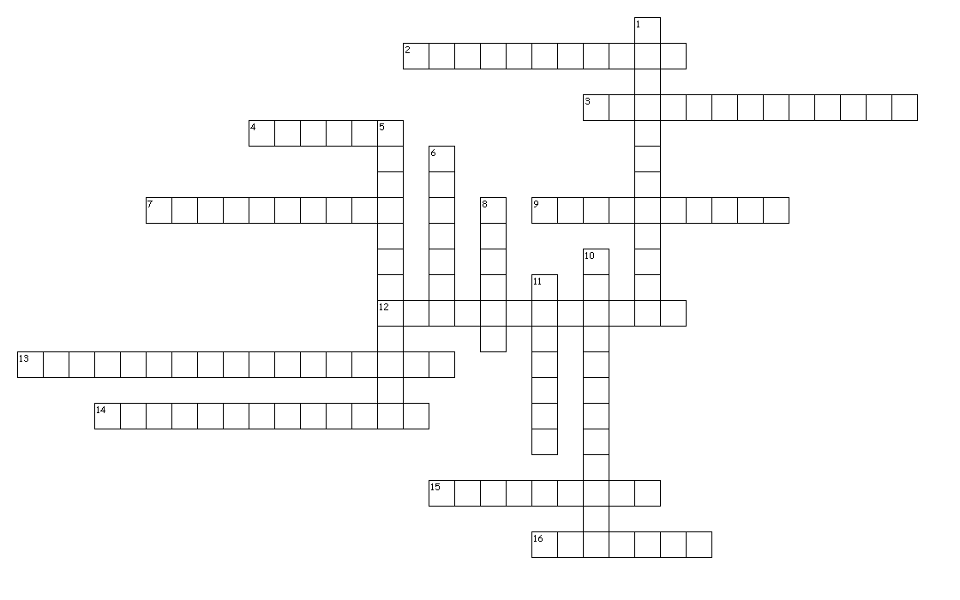

AGGLUTINOGENS | ANGLEOFIMPACT | CONTACTBLOODSTAINS
ERYTHROCYTES | LEUKOCYTES | ORIGINSOURCE
PARENTDROP | PASSIVEBLOODSTAINS | PLASMA
PROJECTEDBLOODSTAINS | SATELLITE | SPATTER
SPATTERS | SPINES | SWIPEPATTERN
THROMBOCYTES | WIPEPATTERN

S | N | I | A | T | S | D | O | O | L | B | D | E | T | C | E | J | O | R | P
N | N | Y | N | V | Q | P | K | N | F | G | K | S | C | R | Q | S | Q | U | S
I | Z | I | X | R | L | B | T | P | Y | Y | N | O | V | G | Z | P | N | Z | E
A | Y | T | A | A | E | A | N | G | L | E | O | F | I | M | P | A | C | T | T
T | F | H | S | T | C | T | J | N | G | G | Z | O | O | P | G | T | T | N | Y
S | I | M | U | O | S | S | T | O | H | P | S | R | N | V | C | T | E | A | C
D | A | E | B | H | D | D | N | A | O | O | I | J | Z | F | Z | E | G | W | O
O | E | N | R | O | N | I | O | R | P | G | D | N | O | Y | Q | R | P | N | K
O | P | L | I | Y | T | S | D | O | I | E | E | E | A | T | U | F | S | T | U
L | J | A | N | U | T | T | P | N | L | A | P | J | R | Y | Z | C | A | H | E
B | Q | B | L | S | N | H | S | A | W | B | F | I | C | E | Q | M | S | R | L
T | L | G | V | E | C | O | R | O | T | Y | E | N | W | V | I | E | J | O | R
C | G | R | R | V | U | U | Q | O | K | T | V | V | E | L | F | Y | S | M | R
A | E | A | G | R | F | B | Z | L | C | S | E | N | I | P | S | D | Z | B | B
T | P | R | C | G | O | E | G | Y | J | Y | E | R | F | S | K | B | Z | O | J
N | P | E | V | S | A | T | E | L | L | I | T | E | S | W | S | K | S | C | F
O | Z | L | S | F | D | Q | J | R | U | G | J | E | Q | G | S | A | O | Y | O
C | N | R | E | T | T | A | P | E | P | I | W | S | S | J | F | U | P | T | Y
D | H | R | B | T | X | U | G | X | M | A | W | I | N | F | K | L | F | E | D
S | M | L | O | P | U | X | N | U | C | Q | H | T | R | T | X | I | Y | S | H

