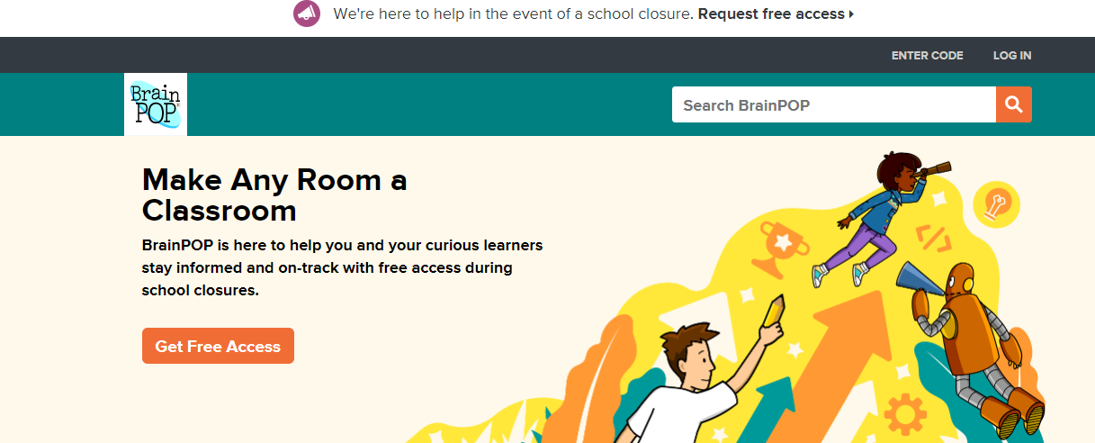
1. When you go to brainpop.com this is the first thing you see. Go to Get Free Access.

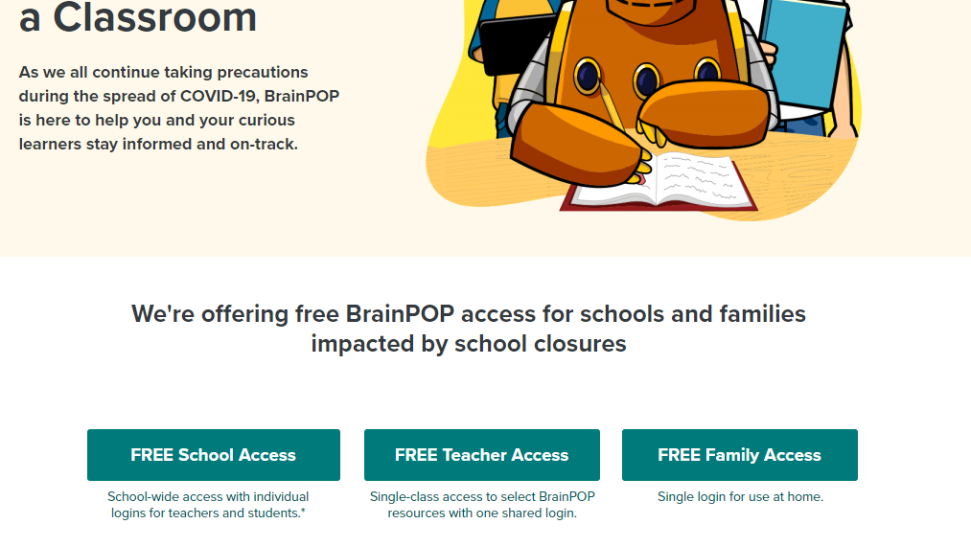
2. Select Free Family Access and follow the directions.
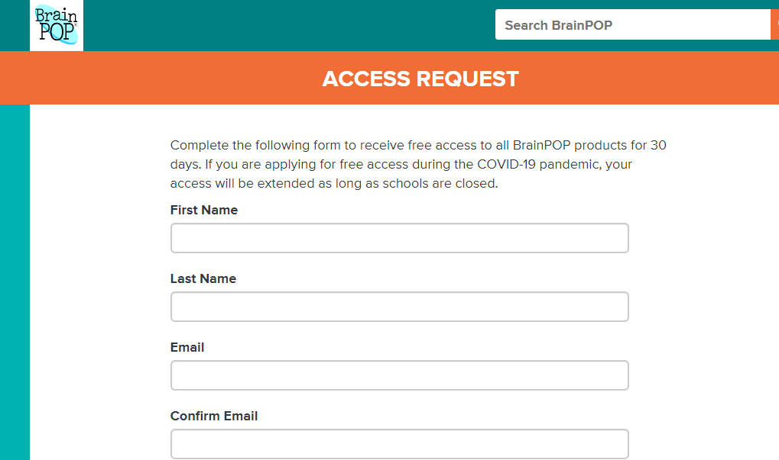
3. Complete this form and you will gain free access!

