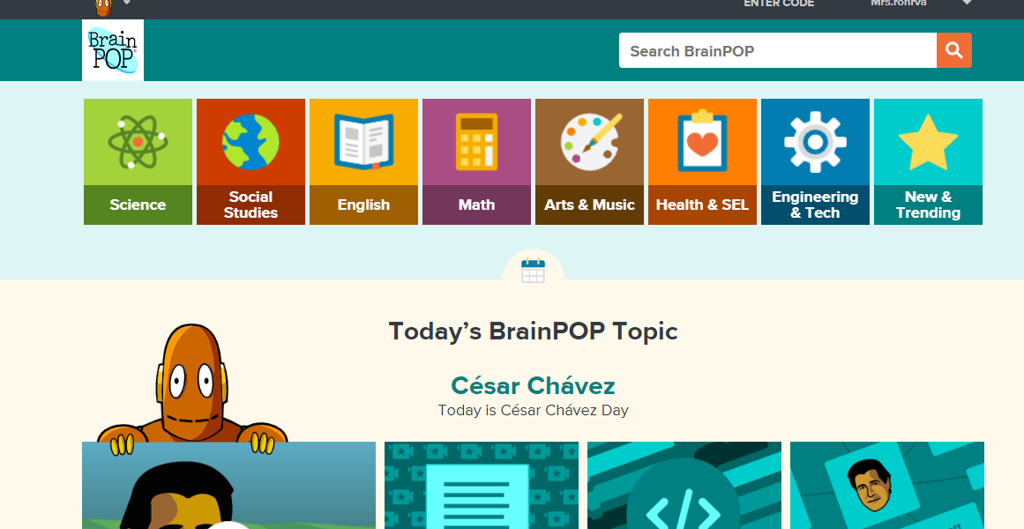
1. This is what the screen looks like when you log in to brainpop with your free account. Please select English.
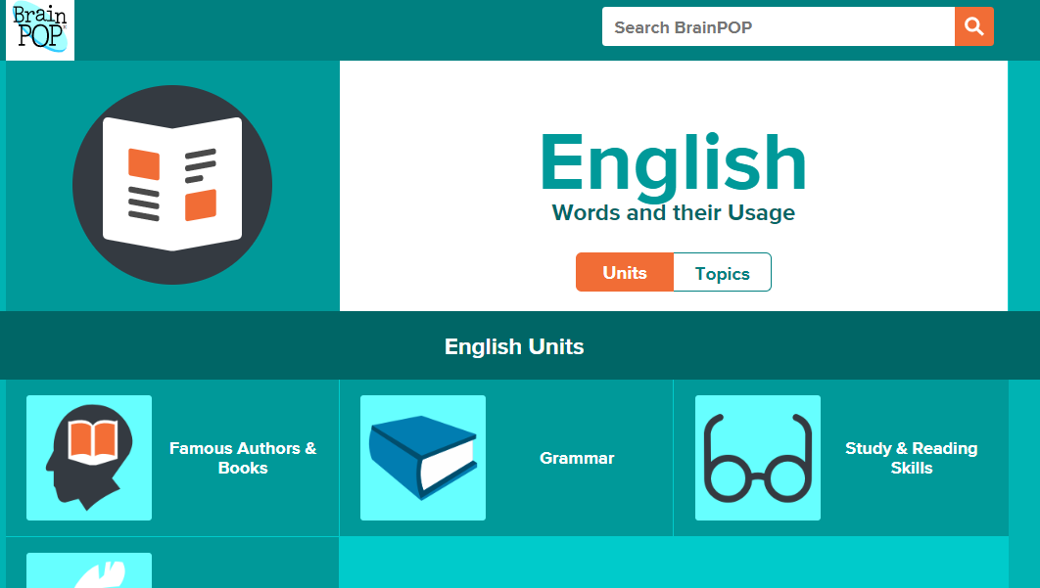
2. This is what the English homepage looks like. Please select Grammar.
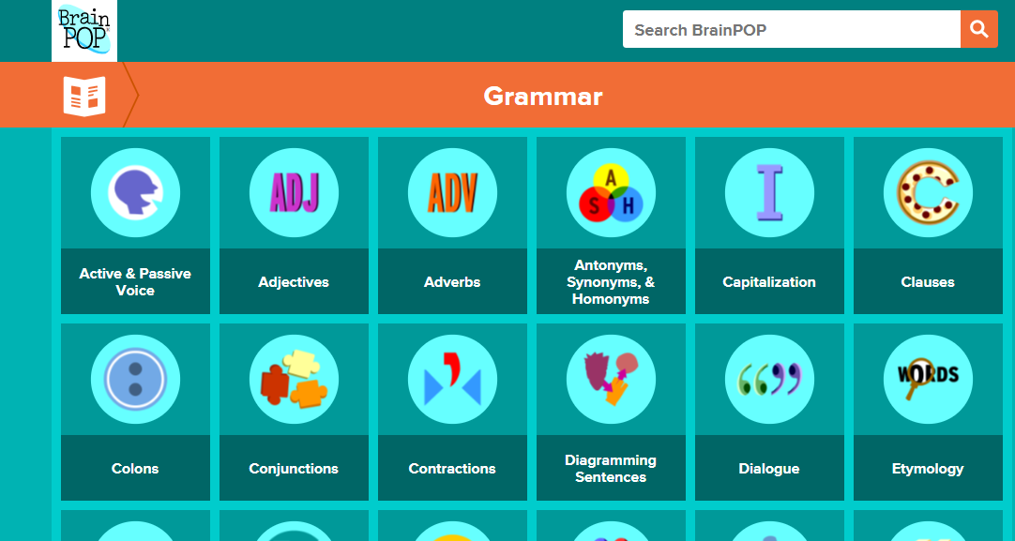
3. You will then come across a list of topics. You have been assigned to watch many but not all of these topics. Your first lesson is on Active and Passive Voice, so click on that.
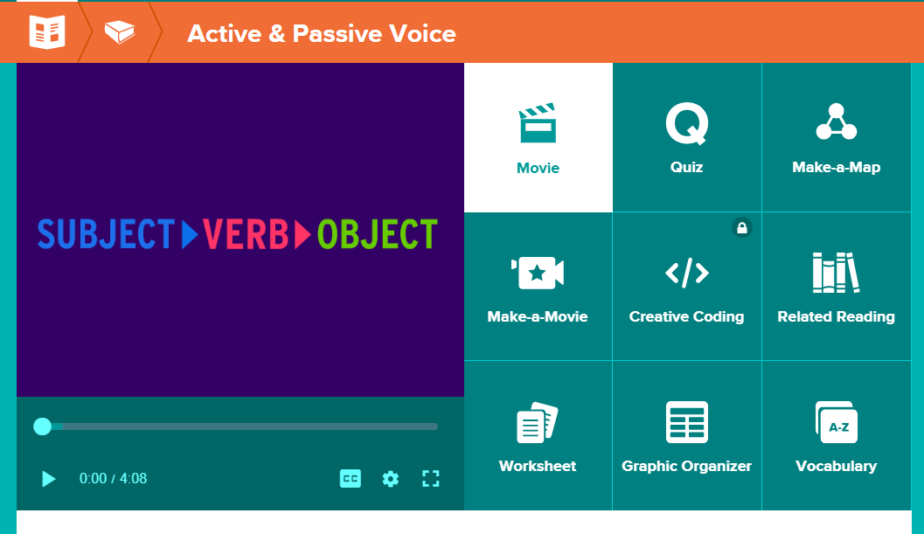
4. Here you will be able to watch the movie, take the quiz an complete the worksheet.

