Name__________________________________________________

Cellular Basis of Heredity

Due Date:

Guide ___________________
Review ___________________
Critical Thinking ___________________
Concept Map ___________________
Crossword ___________________

Name_______________________________

Cellular Basis of Heredity Guide
Define the following terms.
Chromosomes

Haploid

Diploid

Homologous chromosomes

Sexual reproduction

Zygote

Meiosis

Draw and define each term.
Interphase

Prophase I

Metaphase I

Anaphase I

Telophase I

Prophase II

Metaphase II

Anaphase II

Telophase II

Name______________________________________ Score_______
Cellular Basis of Heredity Review
anaphase | interphase | prophase
chromosomes | meiosis | telophase
diploid | metaphase | tetrad
haploid | multiple alleles | zygote
homologous chromosomes

- ______________________________________ are shortened and thickened strands of DNA.
- Two sets of homologous chromosomes that form during prophase are ___________________.
- The phase of meiosis in which DNA shortens and thickens into chromosomes is ________________________________.
- A _____________________________ is the result of two haploid gametes coming together.
- ______________________________ is the process of cell division in which the number of chromosomes is reduced by half to produce gametes.
- A gene with more than two alleles is ___________________________________________.
- ___________________________________ means half the number of chromosomes.
- Matched pairs of chromosomes are ______________________________________________. One from mom and one from dad.
- The phase of meiosis where two or four new cells are formed is _______________________.
- The phase of meiosis where the chromosomes line up at the equator is ____________________.
- __________________________________ happens when tetrads separate and move toward the poles of the cell.
- A complete set of chromosomes is __________________________.
- __________________________________ is the resting phase of the cell.
Draw and describe the phases of meiosis.
- Interphase

- Prophase I

- Metaphase I

- Anaphase I

- Telophase I

- Prophase II

- Metaphase II

- Anaphase II

- Telophase II

- _____Chromosomes line up at the equator. a. interphase
- _____Chromosomes separate and move toward the poles. b. metaphase
- _____DNA shortens and thickens into chromosomes. c. anaphase
- _____Two new cells are formed. d. telophase II
- _____Four new cells are formed. e. prophase
- _____Resting phase, chromosomes are unraveled. f. telophase I
Determine whether the statement is true (T) or false (F).
- _____Humans have 46 pairs of chromosomes.
- _____The first part of meiosis is replication.
- _____When homologous pairs connect they form tetrads.
- _____Chromosomes separate during metaphase.
- _____One set of the homologous pair comes from mom, the other comes from dad.
- _____During interphase the DNA is shortened and thickened into chromosomes.
- _____Meiosis undergoes two cell divisions to make four daughter cells.

- Process of cell division in which the number of chromosomes is reduced by half. Four daughter cells are produced.
  - Haploid
  - Meiosis
  - Mitosis
  - Diploid

- Phase in which chromosomes line up at the equator.
  - Anaphase
  - Metaphase
  - Telophase
  - Prophase

- A cell with a complete set of chromosomes.
  - Haploid
  - Diploid
  - Triploid
  - Comploid

- Phase in which DNA shortens and thickens into chromosomes and form tetrads. This is the first phase of meiosis.
  - Anaphase
  - Metaphase
  - Telophase
  - Prophase

- A cell with half the total number of chromosomes. They are reproductive cells.
  - Diploid
  - Haploid
  - Monoploid
  - Triploid

- Matched pairs of chromosomes. One comes from the mother and the other comes from the father.
  - Homozygous
  - Homologous
  - Homogeneous
  - Homosomes

- Process of making an exact copy of DNA. It is the first thing that happens during Prophase I.
  - Meiosis
  - Replication
  - Transcription
  - Translation

- The resting phase of a cell. DNA is uncoiled.
  - Prophase
  - Metaphase
  - Interphase
  - Anaphase

- Short, thick strands of DNA. Humans get 23 from each parent.
  - RNA
  - Ribosome
  - Chromosome
  - Amino acid

- During this phase tetrads are pulled apart and move toward the poles.
  - Prophase
  - Telophase
  - Anaphase
  - Metaphase

- The result of two haploid gametes coming together.
  - Diploid
  - Zygote
  - Homozygous
  - Replication

- The phase in which new cells are formed.
  - Anaphase
  - Telophase
  - Interphase
  - Metaphase

- Why do cells replicate?
  - To make proteins
  - To make new cells
  - To pass traits on to the next generation
  - To make chromosomes

- Why do cells undergo meiosis?
  - Growth and repair
  - To make reproductive cells
  - To make proteins
  - To make chromosomes

- ___________________________________ is the process of cell division in which the number of chromosomes is reduced by half.
- ______________________________________ is the phase of meiosis characterized by chromosomes lining up at the equator of the cell.
- A cell with a complete set of chromosomes is ___________________________________.
- The first phase of meiosis is ______________________________________. DNA shortens and thickens into chromosomes.
- A cell with half the number of chromosomes is _____________________________________.
- Matched pairs of chromosomes are __________________________________________, one from mom and one from dad.
- The process of making an exact copy of DNA is _____________________________________. It is the first step of meiosis.
- The resting phase of a cell when the chromosomes are uncoiled is _______________________.
- Shortened and thickened strands of DNA are ________________________________________.
- During ______________________________________ tetrads are pulled apart and move toward the poles.
- The result of two haploid gametes coming together forms a _____________________________.
- __________________________________________ is the phase in which new cells are formed.

Name_______________________________________________ Score________
Cellular Basis of Heredity Critical Thinking
- Why do cells replicate before meiosis?

- What are homologous chromosomes?

- How does meiosis explain the Principle of Segregation?

- How does the Chromosome Theory explain the Principle of Segregation?

- How does the Chromosome Theory explain the Principle of Independent Assortment?

- What is the difference between haploid and diploid cells?

- Describe what happens during prophase.

- Describe what happens during interphase.

- Describe what happens during anaphase.

- Describe what happens during telophase.

- Describe what happens during metaphase.

- Why are there two phases in meiosis? (What would happen if it were only one phase?)

- Why are homologous chromosomes like pairs of socks?

Name__________________________________________________ Score________
Cellular Basis of Heredity Concept Map
Use the following terms to create a concept map: telophase, meiosis, resting, metaphase, interphase, chromosomes, 4 gametes, anaphase, equator, prophase, poles,

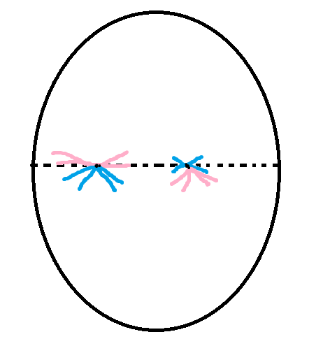
- Identify the phase of meiosis.

____________________________

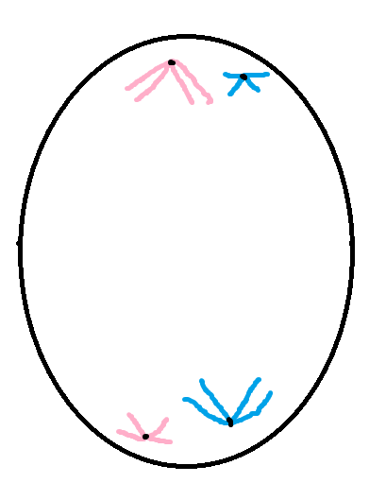

____________________________

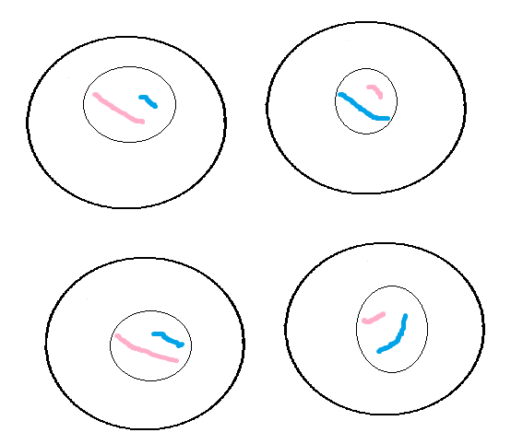

_______________________________

- Why do cells undergo meiosis?

- What are homologous chromosomes?

Cellular Basis of Heredity
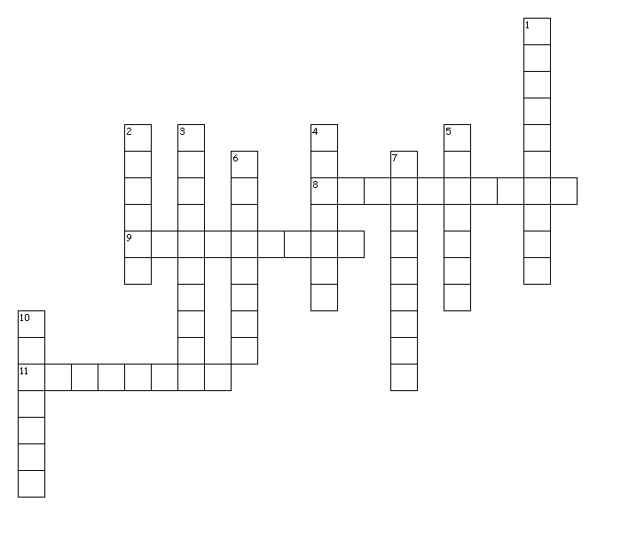

Across
8. resting phase
9. the cell divided into two smaller cells with half the number of chromosomes
11. chromosomes shorten and thicken
Down
1. strands of DNA
2. product of two haploid gametes combining
3. matched pairs of chromosomes, one from each parent
4. process of cell division in which the number of chromosomes is reduced by half
5. 2 sets of DNA
6. chromosome pairs are pulled apart
7. chromosomes line up at the equator
10. half the number of chromosomes

A | K | S | F | S | V | I | H | K | H | I | E | Q | E | E
N | P | Y | U | S | I | A | Q | Z | S | S | M | S | Y | S
A | J | R | C | O | P | S | D | B | A | G | W | Z | L | A
P | L | K | O | L | G | Z | O | H | Q | O | C | A | L | H
H | O | D | O | P | I | O | P | I | V | W | D | Q | C | P
A | W | I | E | T | H | A | L | J | E | L | P | H | H | R
S | D | X | O | U | T | A | C | O | C | M | L | T | N | E
E | Y | E | U | E | M | O | S | O | M | O | R | H | C | T
L | O | T | M | V | I | K | A | E | R | O | J | R | L | N
D | I | O | L | P | I | D | C | H | W | L | H | Q | J | I
V | B | G | N | Z | K | K | O | U | I | U | G | L | O | U
D | F | Y | X | T | O | K | P | M | J | G | J | E | F | X
W | S | Z | Z | Z | Y | Y | F | T | N | O | E | M | T | A
T | E | L | O | P | H | A | S | E | Y | Z | Y | Q | W | K
K | C | A | L | B | I | K | N | Y | O | E | F | G | T | Q

ANAPHASE | CHROMOSOME | DIPLOID
HAPLOID | HOMOLOGOUS | INTERPHASE
MEIOSIS | METAPHASE | PROPHASE
TELOPHASE | ZYGOTE

Cellular Basis of Heredity
