Genetics Lesson 3
Cellular Basis of Heredity

Quiz Date:

Vocabulary
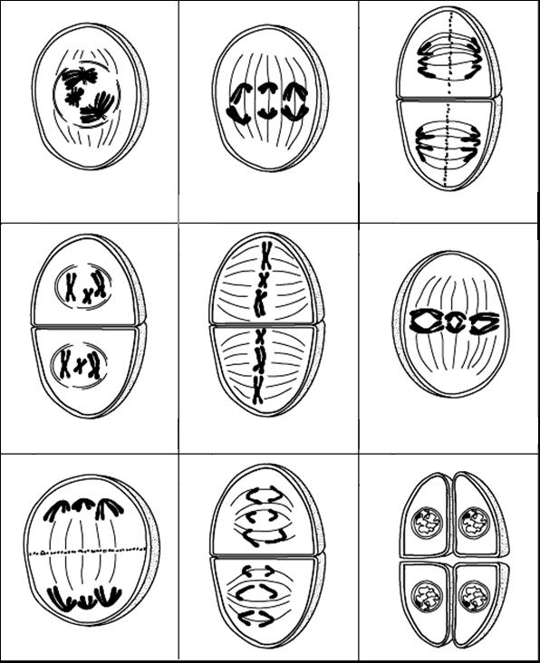

Chromosomes
What is the purpose of meiosis?

Why are there two phases in meiosis?

What are homologous chromosomes?

How many chromosomes are there after Prophase I?

- When cells divide DNA thickens and spirals into strands called chromosomes
- Multicellular organisms are made of two kinds of cells—reproductive cells and somatic cells
- Reproductive cells contain a single set, or haploid number, of chromosomes
- For humans, reproductive cells contain 23 chromosomes
- Somatic cells, or body cells, contain 2 sets, or a diploid number of chromosomes
- For humans, somatic cells have 46 chromosomes
- The 46 chromosomes in somatic cells are 23 matched pairs
- Homologous chromosomes-matched pairs of chromosomes, one pair from each parent
- Homologous chromosomes are like a pair of socks, they are the same size and shape, however they are not identical
- Each parent donates 23 chromosomes, genes on the chromosomes code for specific traits
  - For example, each parent donates a gene for blood type, the mom’s genes will be on one chromosome and the dad’s gene with be on another chromosome, they are matched pairs

Asexual and Sexual Reproduction
What is the difference between a diploid cell and a haploid cell?

- Asexual reproduction-results in offspring that are identical to the parent
- Sexual reproduction-a new individual is formed after a female gamete is fertilized by a male gamete
- The haploid gametes combine for form a zygote, which carries genetic material from both parents
- A zygote contains 2 complete sets of chromosomes
- All cells in the body are diploid, except for gametes, they are haploid
Meiosis
- How does an organism with diploid cells produce haploid gametes?
- The change occurs during a process called meiosis
- Meiosis-a process of cell division in which the number of chromosomes is reduced by half
Interphase

Interphase
- Before meiosis begins, the chromosomes replicate, as a result the nucleus contains double the number of chromosomes
- The chromosomes at this point are folded (still in a double helix, but not wrapped up like a chromosome) like spaghetti

Prophase I
Beginning Prophase I

- During this phase the chromosomes condense into short, thick rods
- Each chromosome is now double, containing 2 chromotids
- Chromotid-a single chromosomal strand
- Homologous pairs of chromosomes come together on the spindle fibers
- Spindle fibers-strings that pull chromotid pairs in a cell
- There are 4 chromotids joined together called tetrads
Metaphase I
- The tetrads move along spindle fibers until they reach the equator of the cell
End of Prophase I

Metaphase I

Anaphase I
Anaphase I

- The homolgous chromosomes are pulled apart so that the pair of chromotids from each tetrad move toward opposite poles of the cell
- This is a random process

Telophase I
- The cell then divides into two smaller cells
- Each new cell contains one homologous chromosome from each original pair
- The new cells are not identical since homologous chromosomes do not contain identical genetic information

Telophase I

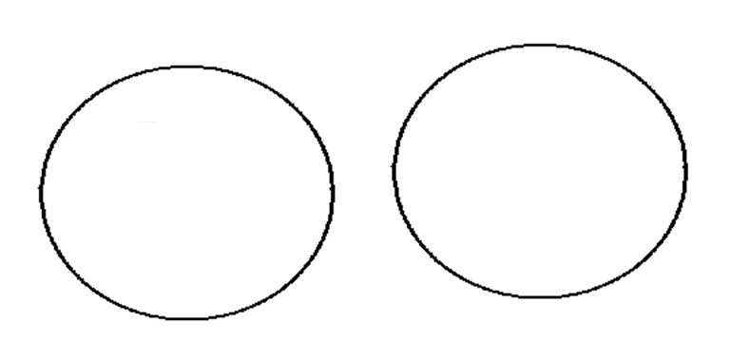

Interphase
- The chromotids uncoil, they do not replicate
Interphase

Prophase II
- The chromotid pairs condense and thicken again
Prophase II

Metaphase II
- Each chromotid moves along a spindle fiber until it reaches the equator
MetaphaseII

Anaphase II
- The chromotids of each pair separate and move toward opposite poles of the cell
- Each individual chromotid is now called a chromosome
- The cell then divides
Anaphase II

Telophase II
- Once the chromosomes reach their destination a new nucleus forms around them and 4 new cells are formed
- As a result of meiosis, one diploid cell undergoes two divisions to form 4 haploid cells with only half as many chromosomes as the original cell
Telophase II

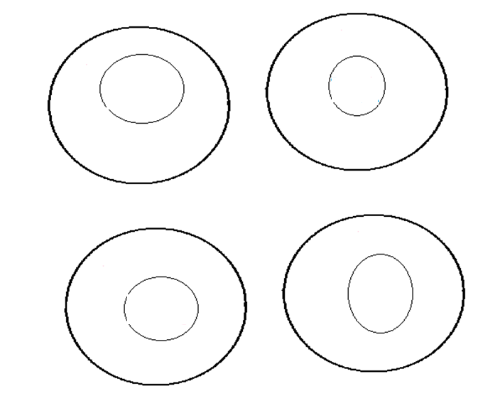

Meiosis
During which phase of meiosis do chromotids line up at the equator of the cell?

During which phase of meiosis do chromotids get pulled apart toward the poles of the cell?

During which phase of meiosis do 4 new cells form?

During which phase of meiosis does DNA shorten and thicken into chromosomes?

During which phase of meiosis do chromosomes unravel and “rest”?
- The new combination makes offspring different from their parents, this is why siblings resemble each other, but are not identical
- 23 chromosomes can align 8 million ways
Chromosome Theory of Inheritance
- Mendel’s experiments were ignored until chromosomes were discovered
- Scientists found Mendel’s “factors were located on the chromosomes
- The chromosome theory makes cells the basis for Mendel’s laws
- According the chromosome theory, genes occur in pairs because they are on chromosomes which also occur in pairs
- One allele comes from each parent because one chromosome comes from each parent
- The Chromosome Theory explains the Law of Segregation; alleles segregate independently because they are located on homologous chromosomes, which segregate during meiosis
- The Chromosome Theory explains the Law of Independent Assortment because genes on separate chromosomes sort independently because the chromosomes segregate randomly during meiosis

