Name__________________________________________________

DNA
and
Chromatography

Due Date:

Guide ___________________
Review ___________________
Critical Thinking __________________
Concept Map ___________________
Crossword ___________________

DNA and Chromatography Guide
DNA
nucleotides
CODIS
chromatography
mixture
compounds
solutions
solute
solvent

Name__________________________________________________ Score________
DNA and Chromatography Review
DNA | chromatography | compounds | solute
nucleotides | mixture | solutions | solvent
CODIS

- _________________________________________ is the database maintained by the FBI that is used to find matches to unknown DNA samples.
- Mixtures in which one substance is dissolved in another are ___________________________.
- _________________________________ is the molecule that contains the genetic material of the cell.
- Pairs of nitrogen bases in DNA that make the genetic code are __________________________.
- ________________________________________________ is the physical separation of a mixture into its individual components.
- A ________________________________________ is the substance that does the dissolving.
- The substance that is dissolved is the ______________________________________.
- _______________________________________ are two or more elements that are chemically combined.
- Two or more substances that are mixed together, but not chemically combined are ________________________________________.

Match the nitrogen bases.
- _____adenine a. adenine
- _____guanine b. guanine
- _____thymine c. thymine
- _____cytosine d. cytosine

- _____gets dissolved a. solvent
- _____chemically combined b. solute
- _____dissolves c. mixture
- _____not chemically combined d. compound

- _____inks and dyes a. paper chromatography
- _____gasoline b. thin-layer chromatography
- _____plant pigments c. gas chromatography
- _____composition of chemicals d. liquid chromatography
Determine whether the statement is true (T) or false (F).
- _____DNA found at a crime scene is always useful for identification.
- _____DNA can identify victims even when a body can’t be found.
- _____Chromatography tells investigators what items found at a crime scene are made of.
- _____In a solution, the solute dissolves the solvent.
- _____Mixtures can be separated by chromatography, because chromatography is a physical process.
- Where is DNA located?
  - Nucleotides
  - Nitrogen bases
  - Chromosomes
  - Backbone

- The order of nitrogen bases in DNA determines
  - The nucleotides
  - The backbone
  - The deoxyribose
  - The genetic code

- DNA found at a crime scene can
  - Link a suspect to the evidence
  - Eliminate a suspect
  - Identify a victim
  - All of the above

- Not all DNA collected at a crime scene is useful because
  - It may get damaged by environmental conditions
  - Many people have the same DNA
  - DNA is not reliable for identifying suspects
  - There is no national database for DNA profiles

- Mixtures are different from compounds because
  - Mixtures are made of two or more substance
  - Mixtures make compounds
  - Mixtures and compounds are the same thing
  - Mixtures are not chemically combined

- Chromatography can help investigators
  - Match ink from a note and a pen
  - Match makeup from a victim found on a suspect’s clothes.
  - Match plants to a crime scene
  - All of the above

- CODIS is the
  - Central organization of DNA identification system
  - Combined DNA index system
  - Combined DNA identification system
  - Collection of DNA identities and surveillance

- An example of a compound is
  - Air
  - Salt
  - Fog
  - Soda pop

- How is DNA used as evidence?

- Give an example of how chromatography can help solve a crime.

- Describe the structure of a DNA molecule.

Name_______________________________________________ Score________
DNA and Chromatography Critical Thinking
- How is DNA used as evidence? Give three examples.

- What is chromatography used for?

- What are solutions? How are they different from mixtures?

- What kind of evidence can investigators get from chromatography?

- What is CODIS and how is it used?

- What are the nitrogen bases and how are they paired together?

- What is the difference between a compound and a mixture?

Name_____________________________________________ Score________
DNA and Chromatography Concept Map
Use the following terms to create a concept map:paper, plant pigments, inks and dyes, chromatography, gasoline,thin-layer,liquid,composition of chemicals, gas.

- Describe the structure of DNA.

- What factors affect DNA?

- What is chromatography?

- What is a mixture?

- What is a compound?

DNA and Chromatography
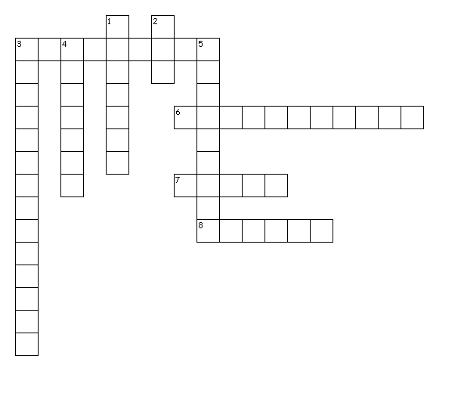
Across
3. two or more elements that are chemically combined
6. pairs of nitrogen bases in DNA that make the genetic code
7. database maintained by the FBI that is used to find matches to unknown DNA samples
8. substance that is dissolved
Down
1. substance that does the dissolving
2. molecule that contains the genetic material of the cell
3. physical separation of a mixture into its individual components
4. two or more substances that are mixed together, but not chemically combined.
5. mixtures in which one substance is dissolved in another

Y | N | L | L | J | K | T | Q | V | S | J | S | H | C | G | W | S | U | X | H
N | H | U | J | Y | W | Z | M | D | W | P | E | L | Y | T | D | O | M | F | G
E | G | P | R | W | R | C | N | J | G | C | D | X | U | W | Y | L | Q | X | M
G | M | L | A | P | L | U | S | O | C | S | I | V | V | Y | O | V | H | H | Y
I | W | I | F | R | O | Q | S | O | L | U | T | I | O | N | S | E | A | I | D
Z | S | C | X | P | G | S | I | D | O | C | O | W | S | A | D | N | J | N | T
L | J | G | M | T | R | O | L | K | H | I | E | L | S | S | H | T | S | V | D
A | S | O | N | U | U | J | T | Z | D | A | L | V | T | V | X | O | B | O | L
B | C | B | J | R | L | R | W | A | F | N | C | Y | L | O | L | Q | K | T | R
F | E | J | J | X | X | Y | E | U | M | L | U | K | K | U | O | W | E | A | E
S | R | W | V | S | G | N | X | M | B | O | N | C | T | O | V | J | H | U | T
B | C | F | L | K | E | Y | P | C | A | T | R | E | A | L | G | K | M | B | T
I | T | J | Q | M | Z | V | D | O | E | C | U | H | I | E | R | V | G | O | L
A | K | C | X | N | Q | J | H | C | Z | K | E | O | C | F | Y | G | P | T | R
E | N | X | V | D | P | D | B | B | M | U | J | O | Y | X | R | W | T | M | D
E | Y | S | E | C | H | T | L | L | V | M | G | G | C | V | Z | A | D | Z | C
G | Y | D | C | G | I | H | X | A | R | O | K | R | H | J | K | V | T | F | K
N | S | M | I | A | V | Q | T | G | V | Q | X | H | D | N | V | B | P | I | M
K | E | E | L | H | L | T | T | L | X | W | Z | Z | S | M | O | N | O | P | H
K | B | X | F | F | Z | H | U | O | D | T | B | A | D | O | H | P | W | P | X

CHROMATOGRAPHY | CODIS | COMPOUNDS
DNA | MIXTURE | NUCLEOTIDES
SOLUTE | SOLUTIONS | SOLVENT

