Forensics Lesson 6
DNA and Chromatography

Quiz Date:

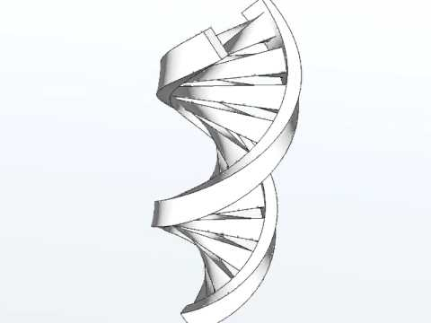
Vocabulary

What is DNA?
- DNA stands for deoxyribonucleic acid and contains genetic information. It is found on chromosomes located in the nucleus of our cells.
What makes up DNA?
- The sides or backbone of the DNA molecule are made up of sugar (deoxyribose) and phosphate molecules.
- The rungs that form the middle of the molecule are made up of pairs of nucleotides or nitrogen bases. Adenine (A) pairs with thymine (T), while guanine (G) always pairs with cytosine (C).
- The order of the bases determines the genetic code.
How is DNA used as evidence?
- Each person’s DNA is different from other people (except identical twins).
- DNA collected from a crime scene can either link a suspect to the evidence or eliminate a suspect, similar to the use of fingerprints.
- DNA can identify a victim through DNA from relatives, even when no body can be found.
- DNA can link crime scenes together by linking the same perpetrator to different scenes locally, statewide, and across the nation.
- DNA can place an individual at a crime scene, in a home, or in a room where the suspect claimed not to have been.
- DNA can refute a claim of self-defense and put a weapon in the suspect's hand.
- It can change a story from an alibi to one of consent.
What factors affect DNA evidence?
- Several factors can affect the DNA left at a crime scene, such as environmental factors (e.g., heat, sunlight, moisture, bacteria, and mold).
- Therefore, not all DNA evidence will result in a usable DNA profile. Further, DNA testing cannot identify when the suspect was at the crime scene or for how long.
What is CODIS?
- CODIS stands for Combined DNA Index System, which is an electronic database of DNA profiles that can identify suspects.
- DNA profiles from individuals convicted of certain crimes, such as rape, murder, and child abuse, are entered into CODIS and help officers identify possible suspects when no prior suspect existed.
Chromatography
What is chromatography?
- Chromatography (from Greek word for chromos for colour) is the collective term for a family of laboratory techniques for the separation of mixtures.
- It involves passing a mixture which contains the analyte through a stationary phase, which separates it from other molecules in the mixture and allows it to be isolated.
- Chromatography is the physical separation of a mixture into its individual components.
- We can use chromatography to separate the components of inks and dyes, such as those found in pens, markers, clothing, and even candy shells.
- Chromatography can also be used to separate the colored pigments in plants or used to determine the chemical composition of many substances.
Examples of Chromatography
Liquid Chromatography
- Used to identify unknown plant pigments & other compounds.
Thin-Layer Chromatography
- Uses thin plastic or glass trays to identify the composition of pigments, chemicals, and other unknown substances.
Gas Chromatography
- Used to determine the chemical composition of unknown substances, such as the different compounds in gasoline.
Paper Chromatography
- Can be used to separate the components of inks, dyes, plant compounds (chlorophyll), make-up, and many other substances
Mixtures & Compounds
Mixture – Two or more substances that are mixed together, but not chemically combined.
Examples of mixtures ...
Air – mixture of gases
Bowl of cereal – mixture of cereal and milk
Soda pop – mixture of soda syrup, water, and CO2 gas
Fog –water suspended in air
Kool-Aid – mixture of water, sugar, and flavor crystals
Compounds – Two or more elements that are chemically combined.
Examples of compounds ...
Salt –Sodium and chlorine combined chemically
Water –Hydrogen and oxygen combined chemically
Carbon Dioxide – Carbon and oxygen combined chemically
Solutions
- Solutions are mixtures in which one substance is dissolved in another.
- Solutions have two parts: solute and solvent
The solute is the substance that is dissolved.
The solvent is the substance that does the dissolving.

