Name__________________________________________________

Forensic Anthropology

Due Date:

Guide ___________________
Review ___________________
Critical Thinking ___________________ Concept Map ___________________
Crossword ___________________

Forensic Anthropology Guide
anthropology
biological profile
bone
femur
comingling
sexual dimorphism
pelvis
teeth
Name________________________________________________ Score________
Forensic Anthropology Review
anthropology | bone | comingling | pelvis
biological profile | femur | sexual dimorphism | teeth

- A ____________________________________________________ is used for estimating age, sex, stature, and ancestry.
- ____________________________________________ is the material that makes the skeleton.
- The _____________________________________________ are the part of the body used to determine age.
- The part of the skeleton used to determine sex is the ________________________________.
- ____________________________________________________ are the physiological differences between skeletons of different sexes.
- _______________________________________ is the study of the physical aspects of humanity.
- The thigh bone is the ________________________________________.
- ___________________________________________ happens when the remains of two or more individuals are mixed together.

- _____Age` a. skull
- _____Sex b. teeth
- _____Stature c. femur
- _____Ancestry d. pelvis

- _____More than one skeleton. a. anthropology
- _____Difference between male and female. b. sexual dimorphism
- _____Study of humans. c. anatomical position
- _____Placing bones in relation to each other. d. commingling
Determine whether the statement is true (T) or false (F).
- _____ The cause of death can be determined by analyzing the skeleton.
- _____A biological profile includes age, stature and sex.
- _____A victim’s age can be determined by measuring the pelvis.
- _____A large skull always indicates a male victim.
- _____Old injuries can help identify a victim.
- _____Adults have more bones than children.
Determine the part of the skeleton that helps forensic anthropologists determine age (A) and sex (S).
- _____femur length
- _____teeth
- _____skull size
- _____skull bones
- _____pelvis

- The first step a forensic anthropologist takes after finding skeletal remains is to

  - Determine the height and sex
  - Determine whether the material is bone
  - Arrange the bones in the anatomical position
  - Determine whether the bones are human

- Forensic anthropologists can
  - Identify victims
  - Determine the cause of death
  - Identify suspects
  - Both a and b

- Placing bones found at a crime scene in the anatomical position allows forensic anthropologists to
  - Make an inventory of the bones
  - Analyze the bones for signs of trauma
  - Consider the skeleton as a whole, not just its parts
  - All of the above

- A forensic anthropologist determines whether bones found at a crime scene are human by
  - Conducting DNA tests
  - Analyzing hairs found at the crime scene
  - Examining the size, shape , and structure of the bone
  - Examining the bone under a microscope

- When a forensic anthropologist finds comingling at a crime scene
  - More than one victim is present
  - Animal and human bones are mixed
  - Only one victim is present
  - All of the above

- Sexual dimorphism results in
  - Only one sex found at the crime scene
  - Differences between males and females
  - Males and females having the same size skull
  - No difference between the skeletons of males and females

- The age of a victim can be determined by
  - Measuring the femur
  - Measuring the skull
  - Looking at the centers of growth
  - Measuring the size of the hands

- The age of a victim can be determined by
  - Measuring the femur
  - Measuring the skull
  - Looking at the centers of growth
  - Measuring the size of the hands

- Adults differ from children because they have
  - More bones than children
  - Fewer bones than children
  - Bones made mostly of cartilage
  - Bigger spaces between the bones of the skull
- The primary responsibility of a forensic anthropologist is to
  - Identify unknown individuals
  - Determine the time of death
  - Collect microscopic evidence at the crime scene
  - Identify the suspect(s)

- The next step a forensic anthropologist takes after determining the substance is bone is to
  - Place the bones in the anatomical position
  - Determine whether there is comingling
  - Determine whether the bones are human or animal
  - Determine the age of the person

- Teeth help to determine age because
  - Teeth grow throughout a person’s life
  - Teeth develop in a specific sequence
  - DNA can be found in teeth
  - Teeth never decompose

Name__________________________________________________ Score________
Forensic Anthropology Critical Thinking
- Describe the steps a forensic anthropologist follows after the discovery of skeletal remains at a crime scene.

- What types of information can a forensic anthropologist get from skeletal remains?

- What are three differences between male and female skeletal remains?

- How is age determined using skeletal remains?

- What is forensic anthropology?

Name___________________________________________________ Score________
Forensic Anthropology
Use the following terms to create a concept map: teeth, age, femur, skull size, sex, skeleton, skull bones, pelvis.

- How can an investigator determine whether bone is human or animal?

- What is anatomical position

- What is comingling?

- What is the biological profile?

- What is sexual dimorphism?

Forensic Anthropology
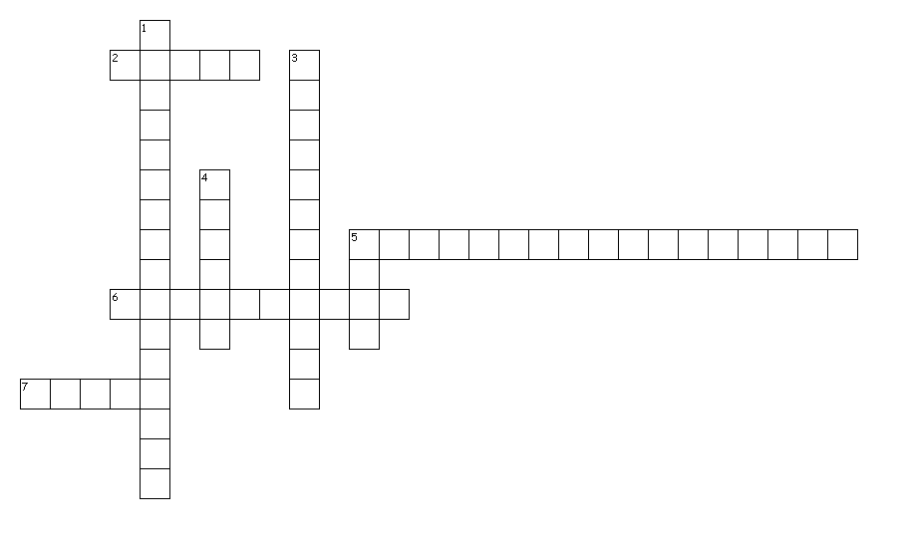
Across
2. thigh bone
5. estimating age, sex, stature, and ancestry
6. When the remains of two or more individuals are mixed together
7. part of the body used to determine age
Down
1. physiological differences between skeletons of different sexes
3. the study of the physical aspects of humanity
4. part of the skeleton used to determine sex
5. material that makes the skeleton

E | J | T | B | P | S | S | I | L | L | W | C | X | Z | V | V | M | Y | M | V
P | L | E | N | O | B | R | P | T | F | V | F | T | V | J | O | S | Z | O | J
N | Q | I | I | C | F | E | I | O | T | X | F | A | N | R | Y | I | V | G | Z
R | V | V | F | C | C | J | X | T | R | I | E | T | N | S | P | H | A | G | Y
Y | B | F | F | O | T | C | A | D | F | F | D | P | T | E | W | P | Y | J | R
P | I | P | Y | T | R | G | L | O | L | V | H | Y | F | A | S | R | K | D | X
L | E | C | E | M | N | P | O | H | A | X | G | Y | R | L | B | O | H | L | Y
D | P | E | M | Z | I | K | L | A | V | O | R | X | X | B | P | M | P | T | X
H | T | E | K | F | L | D | O | A | L | P | V | O | Q | S | Q | I | V | E | E
H | E | N | L | C | P | S | Y | O | C | B | H | F | Y | F | D | D | H | U | U
W | G | K | R | V | L | C | P | L | B | I | B | L | B | E | K | L | S | R | H
J | C | X | T | X | I | O | W | L | L | W | G | C | P | M | U | A | T | X | G
B | R | K | F | U | R | S | R | B | Q | T | G | O | Y | U | M | U | B | B | N
P | H | B | S | H | R | G | Q | X | W | U | C | N | L | R | E | X | T | R | Q
O | M | F | T | D | X | F | T | P | P | B | T | B | Y | O | A | E | C | O | G
I | Z | N | Z | W | X | F | P | O | L | R | D | I | H | F | I | S | T | A | T
N | A | X | Q | W | M | N | T | A | Q | K | C | D | A | D | L | B | A | D | U
R | V | F | H | K | B | Q | W | I | M | X | Q | J | N | O | R | Q | W | I | D
C | O | M | I | N | G | L | I | N | G | X | F | X | U | G | N | K | R | Y | A
P | A | L | F | C | M | C | I | Z | R | M | O | H | S | L | L | J | J | F | K

ANTHROPOLOGY | BIOLOGICALPROFILE | BONE
COMINGLING | FEMUR | PELVIS
SEXUALDIMORPHISM | TEETH

