Forensics Lesson 9
Forensic Anthropology

Quiz Date:
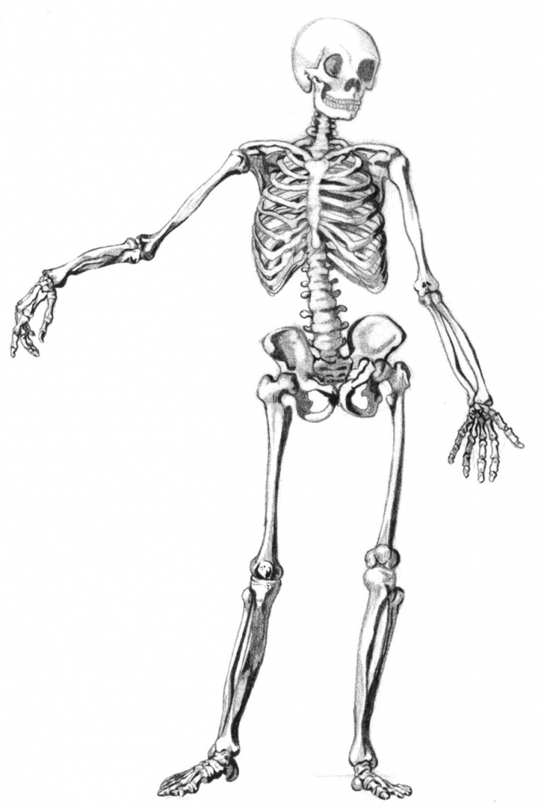

Vocabulary

FORENSIC ANTHROPOLOGY
- Forensic anthropology is the application of anthropology to criminal investigations.
- It incorporates concepts and methods from biological anthropology (the study of the physical aspects of humanity).
- Identifying unknown individuals is a key part of forensic anthropology.
- Anthropologists assist in identifications primarily by constructing a biological profile.
- This includes estimating age, sex, stature, and ancestry, as well as identifying specific characteristics, like diseases or injuries.
- In addition to helping identify human remains, the anthropologist analyzes injuries that happened around the time of a person's death, which can help determine how a person died.
- To do these things, an anthropologist begins by asking a series of important questions.
Is it bone?
- The first thing the examining anthropologist must determine is whether or not the material is bone.
- A surprising number of other materials may be mistaken for bone on first glance, especially if they are covered with dirt or other substances.
- Ceramic shards, plastic, wood fragments, rocks, small bits of concrete can all be mistaken for bones or bone fragments.
- To ensure the material is bone, the anthropologist cleans the object and examines it closely, under magnification if necessary.

Is it human?
- Once the anthropologist is sure that the material is bone, they must determine whether it came from a human or a non-human animal.
- All mammals share a generalized skeletal template, meaning they all have the same bones in roughly the same locations: a skull, spine (which ends in a tail), ribs (which support the internal organs), and four sets of limb bones.
- However, the shape of the bones and the way they relate to each other, differ between animals.
- By examining the size, shape, and structure of a bone, an anthropologist can determine if it is human.
What bones are present?
- Once a case involves human bone, the investigator must identify which bones (or "elements") are present and which are absent.
- Most anthropologists start this process by placing the elements out on a table as they would be organized in a living person, known as the "anatomical position".
- This serves several purposes.
- First, it creates an informal visual inventory that allows any missing elements to be identified quickly.
- Also, it allows the analyst to work systematically through the entire skeleton, performing a detailed inventory and examining each bone for trauma, pathology, or life history traits.
- Lastly, after examining each bone, the analyst can consider the skeleton as a whole, and look for inconsistencies among elements or patterning of trauma across multiple elements.
- At a recovery site, skeletal inventories are important because they allow searchers and scene responders to know what they might be looking for that they have not already recovered.
- This ensures they make as full a recovery as possible.
- Inventories are also important from a criminalistic perspective for establishing what elements are or are not, present.
- The absence of certain elements can provide a great deal of information regarding perimortem events, and perpetrator behavior.
How many people are represented?
- In addition to establishing which elements are present, anthropologists must determine the number of individuals involved.
- To do this, they look for duplicate elements - for example, two right femora (thigh bones).
- Investigators also consider the condition and size of the bones.
- If the elements do not "match", it could suggest more than one individual.
- When the remains of two or more individuals are mixed together, this is called "comingling".
- It is the anthropologist's job to address the comingling and determine which individuals are represented by which bones.
- This allows each body to be examined separately.
- Establishing the number of individuals is very important, especially if the case involves a crime.
- Multiple individuals may be killed together or separate victims may be dumped in the same place over a longer period of time.
- Sometimes perpetrators may bury many victims together in a mass grave in an attempt to conceal their behavior.
- In all cases, it is very important to the understanding and resolution of the case that the anthropologist be as accurate as possible about how many victims were involved.
Who is the individual
- Anthropologists contribute to the identification of unknown individuals by developing a biological profile: age, sex, stature, and ancestry.
- In addition, the biological profile includes information that may be particular to that person and no one else, such as diseases or injuries which may impact the bone.
Sex
- The first step in developing a biological profile is to determine sex.
- Sex is the biological aspect of an individual, determined by genes, and expressed through primary (e.g. reproductive organs and hormones) and secondary (e.g. musculature, body hair, etc) sexual characteristics.
- In contrast, gender refers to the social expression of a person's identity as it relates to their social role and behavior.
- Gender is generally self-defined.
- Societal and cultural norms may influence gender choice, but an individual may not necessarily identify themselves according to those rules.
- In general, anthropologists do not determine the gender of an individual, but personal effects and cultural materials may suggest a person's gender identification.
- The hormonal and visual differences that make living males and females distinct also create physiological differences between their skeletons.
- This "sexual dimorphism" is most obvious in the pelvic bones and the skull.
- All humans are adapted to walking on two legs, but females must also give birth to relatively large-headed babies.
- These different pressures produce structural differences between males and females that can be used to tell them apart.
- The skull also displays a degree of sexual dimorphism.
- Overall, males tend to have larger skulls than females.
- They also have, on average, greater muscle development and more rugged muscle attachments.
- These differences in size and robusticity can help determine whether an individual is male or female.
- Differences in size and robusticity may also be evident in other elements.
- If the skull and pelvis are not available, measurements of other bones may help determine if an individual is male or female.
- However, investigators must be cautious, as there is considerable overlap between males and females.
Age
- Estimating a person's age at the time of death depends on two fundamental life processes: growth and decline.
- Growth and developmental changes are based largely on the degree and location of bone growth and dental formation and eruption from the gums in immature individuals.
- At birth, our "bones" are mostly soft cartilage.
- As we grow, this cartilage is replaced by hard bone at different centers of growth.
- There are over 300 centers of bone growth in infants which eventually fuse to form the 206 bones in the adult body.
- Since the centers grow and fuse at known rates, anthropologists can use the pattern to estimate age in children and sub adults.
- Similarly, teeth develop and erupt in a specific sequence at specific times during childhood and this timing can also be used to provide an accurate estimate of age in juveniles.

