Name__________________________________________________

Forensic Entomology

Due Date:

Guide ___________________
Review ___________________
Critical Thinking ___________________
Concept Map ___________________
Crossword ___________________

Forensic Entomology Guide
entomology
post mortem interval
interface area
larva
molt
ectothermic
complete metamorphosis
bloated stage
decay stage
post decay stage
entomology | larva | complete metamorphosis | decay stage
post mortem interval | molt | bloated stage | post decay stage
interface area | ectothermic
Name____________________________________________ Score_________
Forensic Entomology Review

- _______________________________________________________ begins when the skin breaks and the gases escape.
- Most of the flesh is gone from the corpse, with only cartilage, bone, and skin remaining is the ______________________________________________________.
- The area between the body and the ground is the _____________________________________.
- The _______________________________________________ begins when the body becomes inflated due to the production of gases.
- Cold blooded animals are ____________________________________________.
- During _____________________________________________________________ there are four stages – egg, larva, pupa, and adult.
- The shedding of an exoskeleton by an insect is ____________________________________.
- _________________________________________ is the study of insects.
- The ______________________________________________________________ is the time between death and the discovery of the body.
- The ________________________________________ is the wormlike stage of an insect’s life cycle.
Put the stages of decay in order from first to last. (use numbers)
- _____Bloated stage
- _____Post-decay stage
- _____Fresh stage
- _____Decay stage
Determine the stage at which each insect arrives at a corpse. Early stage (E), early to late stage (EL) or late stage (L).
- _____Skin beetles
- _____Ham beetles
- _____Carrion beetles
- _____Hide beetles
- _____Rove beetles
- _____Clown beetles
Determine whether the statement is true (T) or false (F).
- _____Temperature data is important for entomologists to know because it affects the activity of insects.
- _____During metamorphosis, the pupa comes before the larva.
- _____The stage of decomposition that smells bad is the bloated stage.
- _____It takes about 8 days for a blowfly to complete its life cycle.
- _____Chemicals in the victim’s body (drugs or poisons) can affect how insects develop on the corpse.

- _____Stage when body fills with gases. a. fresh stage
- _____Stage immediately following death. b. bloated stage
- _____Stage when gases escape. c. post-decay stage
- _____Stage when only bone and skin remain. d. decay stage
Identify the insect as either dipetera (D) or coleoptera (C).
- _____Green bottle
- _____Rove
- _____Carrion
- _____Blow
- _____Clown
- _____Cheese skipper
- _____Flesh

- Factors forensic entomologist consider when examining a corpse include
  - Temperature
  - Position and condition of the body
  - Insects found on and around the body
  - All of the above

- Temperature is important when examining insects because
  - Insects are exothermic
  - Insects are only active when it is warm enough
  - Insects development depends on temperature
  - Both b and c

- Insects found on a corpse can help a forensic entomologists determine
  - Cause of death
  - Location of death
  - Time of death
  - Weapons used

- The first insect to arrive at a corpse is a
  - Carrion beetle
  - Blowfly
  - House fly
  - Skin beetles

- If an investigator found blowfly larva on a corpse, approximately how long has the victim been dead?
  - 12-24 hours
  - 6-8 days
  - 4-5 days
  - It depends on the size of the larva, anywhere from 12 hours to 5 days.

- The last insect to arrive at a corpse is the
  - Blowfly
  - Ham beetle
  - House fly
  - Hide beetle

- Gases build up in a body because of
  - Blowflies
  - Maggots
  - Bacteria
  - Beetle larva

- If a forensic entomologist found skin beetles at a crime scene, he/she could conclude that
  - The person died recently.
  - Decomposition is almost complete.
  - The corpse is in the bloated stage.
  - The copse is in the decay stage.

- Insects can enter the body through
  - The nose
  - The eyes
  - The ears
  - All of the above

- A forensic entomologist found carrion beetles on a corpse. What conclusions can he/she make?
  - Flies have already invaded the body.
  - Skin beetles have invaded the body.
  - The body is in the post decay stage.
  - The temperature outside is too cold for flies.

- Why might wrapping a victim in a plastic tarp hinder a forensic entomologist?
  - The body would be too warm for insects.
  - Insects would not be able to get to the body.
  - The tarp would trap moisture that would drown the insects.
  - It wouldn’t matter because insects can eat through the tarp to get to the body.
- With no external wounds present, why would insects invade the trunk of the body last?
  - The trunk is the thickest part of the body.
  - Insects invade the trunk of the body first.
  - There are no openings for insects to lay their eggs.
  - The trunk is the last part of the body to decompose.

- The tissues are liquefied by
  - Beetles
  - Fly larva (maggots)
  - Bacteria
  - Heat

Name______________________________________________________ Score________
Forensic Entomology Critical Thinking
- What are three pieces of information entomologists get from insect evidence?

- What are the two major orders of insects used in forensic entomology?

- Give one factor that might affect PMI.

- Describe blowfly metamorphosis.

- Why is knowing the weather important for entomologists?

- What happens during the decay stage of decomposition?

- What happens during the fresh stage of decomposition?

- What happens during the post decay stage of decomposition?

- What happens during the bloated stage of decomposition?

Name_______________________________________________ Score___________
Forensic Entomology Concept Map
Use the following terms to create a concept map: fresh stage, immediately after death, post-decay stage, gases escape, bloated stage, only bone and skin remain, decay stage, body fills with gases, stages of decomposition.

Use the following terms to create a concept map: blow, carrion, green bottle, flesh, diptera, clown, cheese skipper, rove, coleopteran, insects.

Forensic Entomology
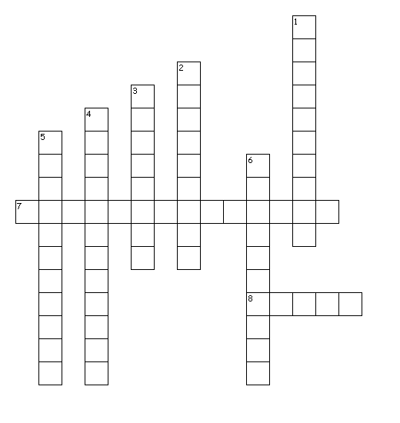
Across
7. Most of the flesh is gone from the corpse, with only cartilage, bone, and skin remaining
8. wormlike stage of an insect’s life cycle
Down
1. Begins when the skin breaks and the gases escape
2. area between the body and the ground
3. metamorphosis with four stages – egg, larva, pupa, and adult.
4. Begins when the body becomes inflated due to the production of gases
5. cold blooded animals
6. study of insects

Y | O | Q | X | A | O | E | R | T | L | O | A | L | P | L | C | E | X | O | E
K | R | F | L | J | W | Y | N | M | U | A | Q | A | M | S | S | C | E | C | G
F | S | Q | P | S | T | B | B | J | S | N | V | V | K | A | E | T | V | F | R
R | X | A | H | Z | V | Z | O | C | Y | O | G | R | T | G | T | O | W | N | O
P | I | N | T | E | R | F | A | C | E | A | R | E | A | M | L | T | T | C | S
F | M | K | P | O | U | O | A | N | V | I | A | T | P | L | O | H | F | C | Y
B | D | Z | Y | I | P | A | T | S | U | F | S | N | O | E | M | E | K | R | I
U | L | A | T | R | C | O | H | H | C | Y | C | I | T | A | C | R | W | H | A
D | P | O | R | K | M | X | W | O | A | Y | V | M | X | M | G | M | U | M | O
D | I | S | A | O | P | B | R | C | K | P | E | E | K | J | I | I | D | E | G
G | R | S | L | T | K | R | E | A | E | G | A | T | S | Y | A | C | E | D | D
C | B | O | U | K | E | D | Z | T | A | C | V | R | T | P | M | J | C | T | T
S | G | Z | W | N | T | D | N | N | O | O | Y | O | R | E | Z | L | H | C | F
Y | C | P | T | S | U | X | S | T | R | Z | Q | M | V | U | V | T | W | Z | L
L | I | A | O | L | K | R | M | T | V | G | I | T | E | X | P | U | U | Q | F
Y | N | P | A | O | W | J | Z | I | A | O | H | S | K | R | E | Y | G | B | J
I | F | A | B | Z | M | R | A | J | Q | G | U | O | K | G | Z | X | W | T | C
V | H | G | Q | I | R | V | F | C | G | T | E | P | S | X | X | K | X | F | X
H | B | O | N | J | C | X | N | R | S | N | F | C | D | Q | J | M | N | Z | Z
Z | I | X | K | O | K | L | S | Y | M | W | N | N | C | I | P | W | J | W | H

BLOATEDSTAGE | DECAYSTAGE | ECTOTHERMIC
ENTOMOLOGY | INTERFACEAREA | LARVA
MOLT | POSTDECAYSTAGE | POSTMORTEMINTERVAL

