Name__________________________________________________

Hair and Fiber Evidence

Due Date:

Guide ___________________
Review ___________________
Critical Thinking ___________________
Concept Map ___________________
Crossword ___________________

Hair and Fiber Evidence Guide
keratin
follicle
cuticle
medulla
cortex
fiber
natural fibers
synthetic fibers
Name________________________________________________ Score________
Hair and Fiber Evidence Review
keratin | cuticle | cortex | natural fibers
follicle | medulla | fiber | synthetic fibers

- The central core of hair is the ________________________________.
- ______________________________________________ are fibers from plants or animals.
- Man-made fibers are ________________________________________________________.
- The outer coating of hair composed of overlapping scales is the _________________________.
- _____________________________________ is the protein that makes hair.
- The protein-rich structure around the medulla that contains pigment is the ________________.
- The _________________________________________ is the structure that produces hair.
- The smallest unit of a textile material is a _________________________________.

- _____Outer coating of hair. a. medulla
- _____Contains the pigment of hair. b. cortex
- _____Central core of hair. c. cuticle
Put in a list from most simple to most complex (use numbers).
- _____yarn
- _____fiber
- _____fabric

Determine whether the fiber is natural (N) or synthetic (S).
- _____rayon
- _____cotton
- _____polyester
- _____wool
- _____nylon
Determine whether the hair structure distinguishes between different humans (H) or between different species (S).
- _____cortex
- _____medulla
- _____cuticle
Determine whether the statement is true (T) or false (F).
- _____Hair follicles produce hair.
- _____Cross transfer occurs when fibers are transferred from the victim to the suspect.
- _____Nuclear DNA is found in the cortex.
- _____Hair is made of keratin.

- How is hair like a pencil?

- Hair is composed of the protein
  - Follicle
  - Keratin
  - Cuticle
  - Cortex

- The outer coating of a hair.
  - Medulla
  - Root
  - Cuticle
  - Cortex

- Synthetic fibers are made
  - By plants
  - By animals
  - By plants and animals
  - By humans

- Wool comes from
  - Cows
  - Sheep
  - Petroleum
  - Rabbits

- Fibers make ____________________________ which is used to make ____________________.
  - Wool and yarn
  - Yarn and polyester
  - Wool and fabric
  - Fabric and wool

- The part of a hair that is used to distinguish between two different people is the
  - Medulla
  - Cortex
  - Root
  - Cuticle

- Opacity of hair is
  - Continuous structure
  - Texture
  - Color
  - How much light is able to pass through the hair.

- Which part of a hairs structure contains scales?
  - Medulla
  - Cortex
  - Root
  - Cuticle

- What is cross transfer and what does it tell investigators?

- What kind of information can investigators get from analyzing hair?

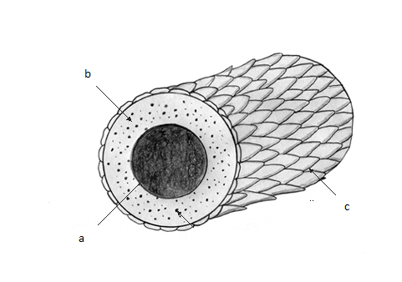
Label the structures of hair.

- _____cuticle
- _____medulla
- _____cortex

Name__________________________________________________ Score________
Hair and Fiber Evidence Critical Thinking
- How does hair and fiber evidence help an investigation? What can it tell investigators?

- How is hair like a pencil?

- What is the difference between natural and synthetic fibers?

- What does each part of a hair tell investigators?

- Where is the DNA of a hair? What can it tell investigators?

Name______________________________________________ Score___________
Hair and Fiber Evidence Concept Map
Use the following terms to create a concept map: hair, medulla, scales, cortex, identify individuals, outer layer, central core, cuticle, surround medulla, color.

- Draw or describe the structure of a human hair.

- What information can investigators get from the cuticle?

- Which part of the hair is used to identify people?

- Which part of the hair determines whether it is human or animal?

- What is cross transfer?

Hair and Fiber Evidence
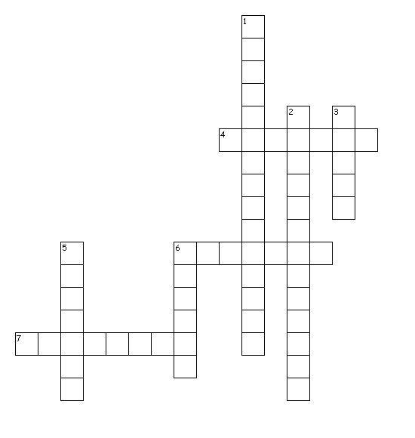
Across
4. protein that makes hair
6. outer coating of hair composed of overlapping scales
7. structure that produces hair
Down
1. man-made fibers
2. fibers from plants or animals
3. the smallest unit of a textile material
5. central core of hair
6. protein-rich structure around the medulla that contains pigment

T | K | H | I | P | H | U | A | L | K | U | Z | X | K | X | O | E | R | U | Y
J | U | C | I | C | Y | Q | W | O | P | T | L | B | R | F | L | I | X | Z | D
L | H | S | M | D | K | E | V | X | R | W | F | J | R | C | L | R | Z | D | R
L | R | J | D | R | L | V | Q | Q | D | I | I | U | I | O | P | O | P | D | F
Q | P | K | P | D | K | P | O | A | B | Y | O | T | D | F | P | C | J | F | A
Y | R | V | Q | R | A | P | F | E | W | B | U | V | O | U | O | P | S | D | D
J | I | Y | E | G | B | Y | R | A | K | C | N | A | P | P | K | A | V | G | R
V | V | G | L | Z | C | V | S | L | H | X | X | U | J | D | X | D | Q | W | J
B | K | C | E | N | H | W | L | K | J | V | K | D | L | Y | D | V | C | S | C
D | X | S | Y | I | A | G | A | Z | L | O | J | M | P | J | Q | C | O | A | Q
J | H | G | P | Q | E | T | K | M | P | U | Q | Z | O | R | Q | B | R | K | H
Y | D | R | F | Y | Z | L | U | W | U | C | J | L | D | F | X | K | T | S | D
B | D | C | S | P | H | T | C | R | S | M | E | D | U | L | L | A | E | Y | E
I | M | I | F | D | M | M | T | I | A | U | A | I | N | Y | H | R | X | I | E
C | I | T | E | H | T | N | Y | S | L | L | Z | N | I | K | O | G | S | Z | O
D | N | J | F | G | L | F | E | Z | L | L | N | L | T | B | W | N | Y | D | A
E | T | T | P | R | C | O | U | F | C | W | O | G | A | E | L | D | Q | M | K
E | C | X | C | D | H | I | B | B | K | K | W | F | R | R | T | E | I | C | B
N | R | I | W | Y | B | L | B | V | G | N | W | O | E | X | L | Y | F | M | D
U | K | C | A | I | I | Z | U | X | A | T | H | K | K | A | N | R | M | H | L

CORTEX | CUTICLE | FIBER
FOLLICLE | KERATIN | MEDULLA
NATURAL | SYNTHETIC

