Forensics Lesson 5
Hair and Fiber Evidence

Quiz Date:

Vocabulary

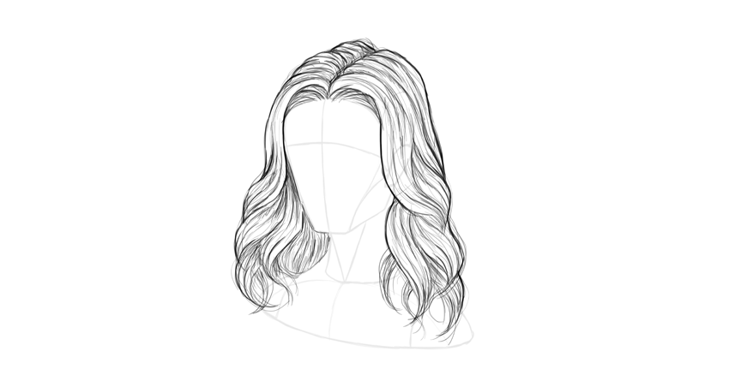

Biology of Hair
- Hair is composed of the protein keratin, which is also the primary component of finger and toe nails.
- Hair is produced from a structure called the hair follicle.
- Humans develop hair follicles during fetal development, and no new follicles are produced after birth.
- Hair color is mostly the result of pigments, which are chemical compounds that reflect certain wavelength of visible light.
- Hair shape (round or oval) and texture (curly or straight) is influenced heavily by genes.
- The physical appearance of hair can be affected by nutritional status and intentional alteration (heat curling, perms, straightening, etc.).
- In order to test hair evidence for nuclear DNA, the root must be present.
- Hair may also be tested using mitochondrial DNA whether or not the root is present.
Hair Structure
- Hair is composed of three principal parts:
- Cuticle-outer coating composed of overlapping scales.
- Medulla-central core (may be absent)
- Cortex-protein-rich structure around the medullas that contains pigment.
- The structure of hair has been compared to that of a pencil with the medulla being the lead, the cortex being the wood and the cuticle being the paint on the outside.
Cuticle
- The cuticle varies in:
- Its scales-how many there are per centimeter, how much they overlap, their overall shape, and how much they protrude from the surface.
- Its thickness
- Whether or not it contains pigment.
- Characteristics of the cuticle may be important in distinguishing between hairs of different species but not useful in distinguishing between different people.
Cortex
- The cortex varies in:
- Thickness, texture and color.
- Distribution of the cortex is perhaps the most important component in determining from which individual a human hair may have come.
- Microscopic examination can also reveal the condition and shape of the root and tip.
Medulla
- The medulla may vary in:
- Thickness, continuity (one continuous structure or broken into pieces) and opacity (how much light is able to pass through it).
- It may also be absent in some species.
- Like the cuticle, the medulla can be important for distinguishing between hairs of different species, but often does not lend much important information to the differentiation between hairs from different people.
Fiber Evidence
- A fiber is the smallest unit of a textile material that has a length many times greater than its diameter.
- A fiber can be spun with other fibers to form a yarn that can be woven or knitted to form a fabric.
- The type and length of fiber used, the type of spinning method, and the type of fabric construction all affect the transfer of fibers and the significance of fiber associations.
- This becomes very important when there is a possibility of fiber transfer between a suspect and a victim during the commission of a crime.
- Matching unique fibers on the clothing of a victim to fibers on a suspect’s clothing can be very helpful to an investigation.
- Whereas the matching of common fibers such as white cotton or blue denim fibers would be less helpful.
- The discovery of cross transfers and multiple fiber transfers between the suspect’s clothing and the victim’s clothing dramatically increases the likelihood that these two individuals had physical contact.
Natural Fibers
- Many different natural fibers that come from plants and animals are used in the production of fabric.
- Cotton fibers are the plant fibers most commonly used in textile materials.
- The animal fiber most frequently used in the production of textile materials is wool, and the most common wool fibers originate from sheep.
Synthetic Fibers
- More than half of all fibers used in the production of textile materials are synthetic or man-made.
- Nylon, rayon and polyester are all examples of synthetic fibers.

