Genetics Lesson 1
Nature of DNA

Quiz Date:

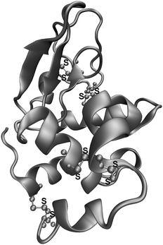
Vocabulary

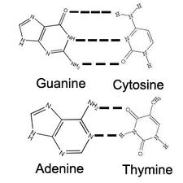
Nucleic Acids
- Nucleic Acids-organic acids made of nucleotides, they control all of the activities of the cell
- DNA-deoxyribonucleic acid, nucleic acid found in the nucleus that contains the genetic information of the cell
Nucleotides
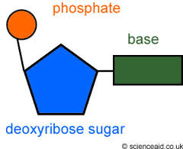
- Nucleotide-An organic molecule made of a 5-carbon sugar, a phosphate group and a nitrogen base
- Each nucleotide contains one of four different nitrogen bases: adenine, thymine, cytosine, guanine
- Nucleotides in DNA are joined together in a long chain
- The sugar of one nucleotide is bonded with the phosphate group of the next nucleotide
Structure of DNA
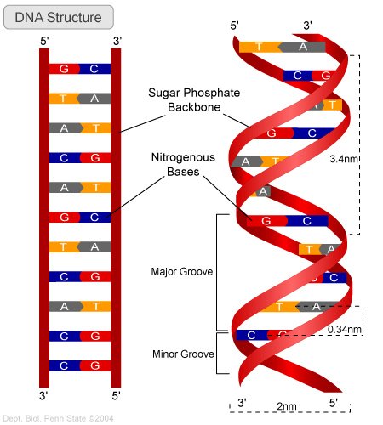
- Erwin Chargaff discovered that the number of adenine bases always equals the number of thymine bases and the number of guanine bases always equals the number of cytosine bases
- Rosalind Franklin bombarded DNA with x-rays and found repeating structures
- In 1953, Francis Crick and James Watson discovered the 3-dimensional shape of DNA
- Crick and Watson concluded that DNA is composed of two long chains of nucleotides arranged in a spiral
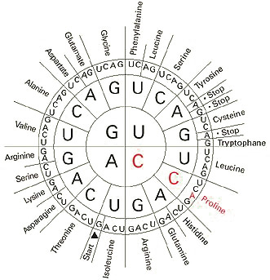
- The structure of the model looks like a twisted ladder called a double helix
- The sides of the ladder are made of nitrogen bases held together by hydrogen bonds
- Adenine always pairs with thymine, A:T or T:A
- Cytosine always pairs with guanine, C:G or G:C
- A strand of DNA with the sequence T-A-G-C-T must have a partner strand with the sequence A-T-C-G-A
DNA Code
- Complimentary-the pattern of base pairing
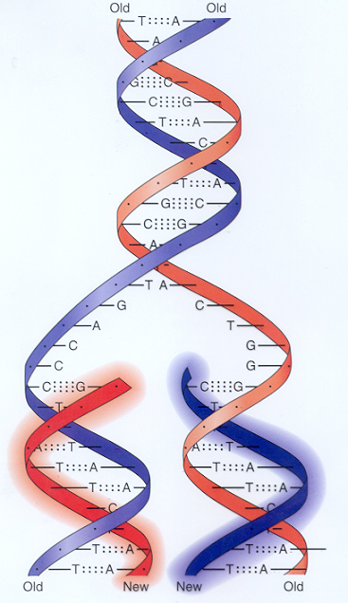
- Proteins are the building blocks of the cell
- Proteins are made by a sequence of amino acids
- A series of 3 nucleotides on a DNA molecule, called a triplet, codes for one amino acid
- There are 20 types of amino acids that make ALL the different proteins
- Genetic code-the “alphabet” of DNA triplets specifying a particular amino acid
Replication of DNA
- In order for a cell to function properly it must have a complete set of genetic instructions
- Since information is carried on the DNA molecule, it is critical that every new cell receive an exact copy of the molecule
- The DNA code is copied by a process of replication
- What is the genetic code for?
- In replication new strands of DNA are made from a supply of nucleotides in the nucleus
Steps of Replication
- Replication begins when enzymes break the hydrogen bonds between the complimentary base pairs
- Separation of the strands occur at many locations on the molecule at the same time
- Where the DNA molecule is separated, bases are exposed
- Enzymes move the free-floating nucleotides to the exposed bases
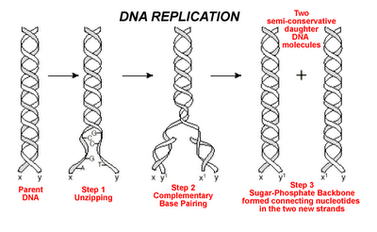
- Other enzymes bond the phosphate of one nucleotide to the sugar of the next
- Separation and pairing of free nucleotides continue until the entire DNA molecule has been replicated
- The two original nucleotide strands serve as a mold for building the complimentary strand
- The process of replication insures that the exact order of bases in a molecule of DNA will be preserved and passed from one generation of cells to the next

Protein Synthesis
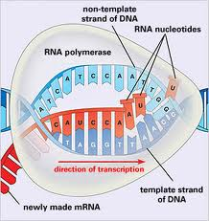
- DNA does not leave the nucleus and proteins are not made in the nucleus
- The genetic code for making proteins is carried out of the nucleus by RNA, ribonucleic acid
- It is like going to the library (nucleus) to make copies of instructions and going home (cell) to build
- Like DNA, RNA is a nucleic acid, however there are important differences
- RNA contains the sugar ribose, DNA contains deoxyribose
- Instead of thymine, RNA contains uracil
- Uracil forms a complimentary pair with adenine
- Molecules of DNA are in a double helix, molecules of RNA have different shapes
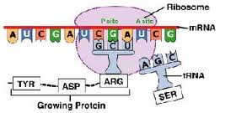
- Messenger RNA or mRNA, carries the blueprint for a particular protein out of the nucleus to specific site on a ribosome
- Ribosomes are organelles that make proteins using the directions from mRNA
- Transfer RNA, or tRNA, attaches to a free amino acid and carries it to the ribosome
- Ribosomal RNA, or rRNA, bonds the amino acids to from protein chains

Transcription
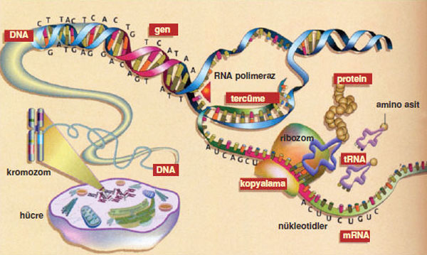
- The process of protein synthesis begins when enzymes open up the portion of DNA that codes for the needed protein
- Only one side of the DNA is transcribed
- Once the DNA locally unwinds, other enzymes help the bonding of free RNA nucleotides to the exposed bases on one of the DNA strands
- The process is similar to DNA replication, except that adenine on the DNA pairs with uracil instead of thymine
- Once complimentary bases are paired, the phosphate end of one RNA nucleotide is bonded to the sugar end of the next
- Once the transcription is complete, the RNA leaves the nucleus and enters the cell to build the protein
Translation
- Once outside the nucleus, mRNA travels to the ribosome
- Translation-the process of building a protein molecule according to the code in mRNA
- tRNA brings the amino acids floating in the cell to the ribosome, drops it off and leaves to find more amino acids
- The ribosome translates the sequence of mRNA bases into a sequence of amino acids to form a protein using rRNA

