Name__________________________________________

Objects in Space

Due Date:

Reading __________________
Guide __________________
Review __________________
Critical Thinking __________________
Concept Map __________________
Crossword __________________
Test Prep __________________

Objects in the Solar System Reading
- What is the current theory on the origin of Earth’s moon?
- Phases
- What are the phases of the moon?
- Eclipse
- Lunar eclipse
- Solar eclipse
- Annular eclipse
- Comet
- Ion tail
- Dust tail
- Nucleus
- Perihelion
- Aphelion
- Asteroids
- Asteroid belt
- Meteoroid
- Meteorite
- Meteor
Objects in the Solar System Guide
Satellite

Phases

Eclipse

Comet

Perihelion

Aphelion

Asteroid

Asteroid belt

Meteoroid

Meteorite

Meteor

Objects in the Solar System Review

satellite perihelion asteroid meteorite
phases aphelion asteroid belt meteor
eclipse comet meteoroid

- A _______________________________________________ is a natural or artificial body that revolves around a planet.
- _______________________________________ are the different appearances of the moon due to varying amounts of sunlight on the side of the moon that faces Earth.
- The point in the orbit of a planet at which the planet is closes to the sun is ____________________________________________.
- A small, rocky body that revolves around the sun is a _____________________________.
- The ______________________________________________________ is the region of the solar system most asteroids occupy, between Jupiter and Mars.
- A _________________________________________ is a very small, rocky body that revolves around the sun.
- A ___________________________________ is a small body of ice and rock that gives off gas and dust in the form of a tail as it passes close to the sun.
- A meteoroid that reaches the Earth's surface without burning up completely is called a ________________________________________.
- A streak of light caused when a meteoroid or comet dust burns up in the Earth's atmosphere before it reaches the ground is a ___________________________________________.
- An _______________________________________________ is an event in which the shadow of one celestial body falls on another.
- The ___________________________________________________ is the point in the orbit of a planet at which the planet is farthest from the sun.

- _____waxing a. moon blocks sun
- _____lunar eclipse b. getting bigger (growing)
- _____waning c. Earth blocks moon
- _____solar eclipse d. getting smaller (shrinking)
Determine whether the statement is true (T) or false (F).
- _____A waning gibbous is almost full.
- _____Comets are closest to the sun when it is at perihelion.
- _____The asteroid belt is between Earth and Mars.
- _____Comets come from the Oort cloud around our solar system.
- _____A solar eclipse only casts a shadow on a small portion of Earth at a time.

- _____streak of light a. meteorite
- _____landed on Earth b. meteoroid
- _____in space c. meteor

- Draw a diagram of a solar eclipse. (Include Earth, moon, and sun)

- Draw a diagram of a lunar eclipse. (Include Earth, moon, and sun)

- Draw and label the phases of the moon. (Use your textbook pages).

- __________________________________________ are small bodies of ice and cosmic dust. (meteor or comet)
- The closest point to the sun in an orbit is called the ___________________________________. (perihelion or aphelion)
- Most asteroids in our solar system are found between ______________________________ and __________________________________. Jupiter and Saturn or Jupiter and Mars
- ______________________________________ are meteoroids that fall to Earth. (meteors or meteorites)
- A naturally formed planetary satellite is a _________________________. (meteor or moon)
- As Earth’s moon waxes, the sunlit fraction we see from Earth becomes ___________________. (larger or smaller)
- When the moon is waning, the sunlit fraction is becoming ____________________________. (larger or smaller)
- If you lived on the far side of the moon, you would never see ____________________________. (Earth or the Sun)
- A natural or artificial body that revolves around a planet.
  - Moon
  - Satellite
  - Meteoroid
  - Both a and b

- ____________________________ the different appearances of the moon during varying amounts of sunlight on the side of the moon that faces the Earth.
  - Satellites
  - Phases
  - Lunar eclipse
  - Solar eclipse

- An event in which the shadow of one celestial body falls on another.
  - Phases of the moon
  - Solar eclipse
  - Lunar eclipse
  - Both b and c
- A small body of ice and rock that gives off gas and dust in the form of a a tail as it passes close to the sun.
  - Comet
  - Meteor
  - Asteroid
  - Meteoroid

- The point in the orbit of a planet at which the planet is closest to the sun.
  - Aphelion
  - Perihelion
  - Lunar eclipse
  - Solar eclipse

- A small, rocky body that revolves around the sun.
  - Meteoroid
  - Asteroid
  - Meteor
  - Comet

- The region of the solar system most asteroids occupy.
  - Oort cloud
  - Kuiper belt
  - Asteroid belt
  - Meteoroid belt

- A very small, rocky body that revolves around the sun.
  - Comet
  - Meteoroid
  - Asteroid
  - Meteorite

- A meteoroid that reaches the Earth’s surface without burning completely.
  - Meteorite
  - Meteor
  - Asterite
  - Comet

- A streak of light caused by meteoroids that burn up in the Earth’s
atmosphere.
  - Meteor
  - Meteorite
  - Shooting star
  - Both b and c

- A comet’s ion tail consists of
  - Dust
  - Electrically charged particles of gas
  - Light rays
  - Comet nuclei

- What is the most current theory for the formation of Earth’s moon?
  - The moon formed from a collision between another body and the Earth.
  - The moon was captured by the Earth.
  - The moon formed at the same time as the Earth.
  - The moon formed by spinning off from the Earth early in its history.

- When do annular eclipses occur?
  - Every solar eclipse
  - When the moon is closet to the Earth
  - Only during full moon
  - When the moon is farthest from the Earth.

Objects in Space Critical Thinking
- What evidence suggests that Earth’s moon formed from a giant impact?

- Why do we always see the same side of the moon?

- How are lunar eclipses different from solar eclipses?

- What is the difference between an asteroid and a meteoroid?

- Do solar eclipses occur at the full moon or at the new moon? Explain why.

- What are perihelion and aphelion?

- What is the Oort cloud and where is it located?

- Relate the position of asteroids in the asteroid belt and their composition (what they are made of).

- Compare: meteor, meteoroid, and meteorite.

- What are the three major types of meteorites?

Objects in the Solar System Concept Map
Use the following terms to create a concept map: meteor, surface, space, meteorite, atmosphere and meteoroid, rocky body.

Use the following terms to create a concept map: solar eclipse, lunar eclipse, shadow of moon, shadow of Earth, shadow on Earth and shadow on moon.

- Why don’t we see solar and lunar eclipses every month?

- What is the difference between waning and waxing?

- How was Earth’s moon formed?

- Why is there a dark side of the moon?

- How are comets different from asteroids?

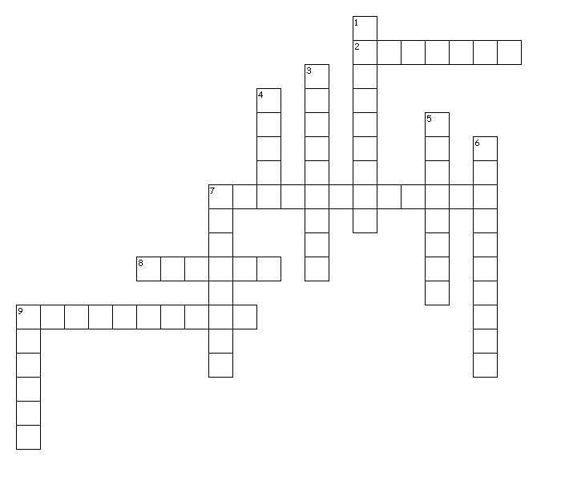
Objects in Space

Across
2. an event in which the shadow of one celestial body falls on another
7. the region of the solar system most asteroids occupy, between Jupiter and Mars
8. a streak of light caused when a meteoroid or comet dust burns up in the Earth's atmosphere before it reaches the ground
9. the point in the orbit of a planet at which the planet is closes to the sun
Down
1. a very small, rocky body that revolves around the sun
3. a meteoroid that reaches the Earth's surface without burning up completely
4. a small body of ice and rock that gives off gas and dust in the form of a tail as it passes close to the sun
5. the point in the orbit of a planet at which the planet is farthest from the sun
6. a natural or artificial body that revolves around a planet
7. a small, rocky body that revolves around the sun
9. the different appearances of the moon due to varying amounts of sunlight on the side of the moon that faces Earth

T | I | H | X | N | G | N | N | M | E | O | R | L | A | X | R | Q | Y | T | P
Z | L | D | V | S | X | S | O | T | E | F | Q | S | F | R | U | K | K | X | G
Z | C | E | P | Y | A | Z | I | G | I | T | T | X | L | W | P | Y | A | G | J
A | S | R | B | X | G | L | L | T | T | E | E | J | A | M | R | I | G | T | M
T | X | A | R | D | L | Y | E | X | R | N | J | O | A | V | S | A | A | G | L
Y | G | E | E | E | I | O | H | O | E | L | U | V | R | J | G | M | P | S | B
Y | B | S | T | H | P | O | I | T | P | A | W | Z | A | I | M | J | H | G | J
J | F | A | E | C | T | D | R | E | S | P | I | L | C | E | T | T | E | T | U
C | S | K | W | S | N | X | E | E | N | F | M | C | V | D | U | E | L | L | N
D | X | A | Y | L | A | E | P | Y | T | H | B | R | N | J | S | G | I | I | Y
M | Y | U | E | C | I | H | B | I | E | S | U | V | R | E | A | W | O | T | T
X | F | T | Q | Q | F | K | P | F | Z | K | A | O | V | W | T | V | N | G | F
H | T | C | A | U | O | Z | T | U | E | K | U | X | K | I | J | G | J | T | P
I | D | P | U | Y | X | U | C | N | R | X | V | H | Q | T | B | E | T | R | R
K | B | Z | H | E | H | C | Y | Q | O | Z | D | Q | E | C | E | V | Z | A | U
G | G | Y | D | F | M | Z | U | V | E | A | P | M | S | F | B | G | J | K | W
S | Q | X | S | K | J | Y | M | Y | T | N | O | H | H | G | P | I | O | M | C
J | B | O | L | Y | M | R | Z | X | E | C | D | I | I | D | W | J | A | Y | D
L | E | Q | V | O | U | E | M | B | M | W | F | R | E | L | Z | G | W | A | K
M | E | T | E | O | R | O | I | D | Q | U | J | I | J | Q | E | D | J | O | S

APHELION | ASTEROID | ASTEROIDBELT
COMET | ECLIPSE | METEOR SATELLITE
METEORITE | METEOROID | PERIHELION PHASES

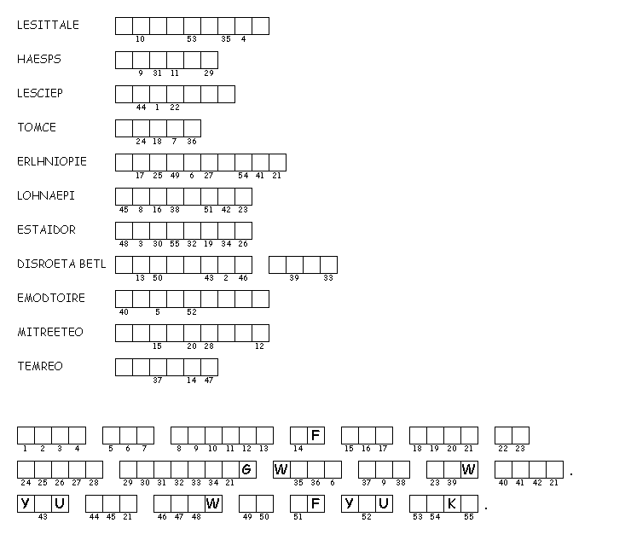

Test Prep
11) By what processes can compounds be broken down?
A) physical changes
B) chemical changes
C) compound changes
D) either physical or chemical changes

12) What kind of pure substance forms when two elements chemically combine?
A) an element
B) a compound
C) a mixture
D) a solution

13) Which of the following is the process in which particles of substances separate
and spread evenly throughout a mixture?
A) filtration
B) dissolving
C) concentration
D) distillation

14) How can a compound be broken down?
A) by physical changes
B) by chemical changes
C) by crushing
D) by cooling

15) In which of the following are particles of two or more substances evenly mixed so
they appear to be a single substance?
A) a compound
B) a mixture
C) a solution
D) an element

