Name__________________________________________________

Patterns of Inheritance

Due Date:

Guide ___________________
Review ___________________
Critical Thinking ___________________
Concept Map ___________________
Crossword ___________________

Name____________________________________

Patterns of Inheritance Guide
Define the following terms.
Gregor Mendel

Traits

Gametes

Fertilization

Hybrid

P1 generation

F1 generation

Dominant

Recessive

Principle of Segregation

Principle of Independent Assortment

Genotype

Phenotype

Homozygous

Heterozygous

Find the number of brown eyed babies for each cross. Brown eyes are dominant.
BB x bb Bb x bb Bb x Bb

Name________________________________________ Score________
Patterns of Inheritance Review
allele | fertilization | homozygous | principle of independent assortment
dihybrid cross | gamete | monohybrid cross | principle of segregation
dominant | genotype | P1 generation | recessive
F1 generation | heterozygous | phenotype | traits

- The ______________________________ is the offspring generation.
- The inheritance of alleles for one trait does not affect the inheritance of alleles for another trait is the ___________________________________________________________.
- Inherited characteristics transmitted from one generation to the next are ____________________.
- A _______________________________ trait prevents the recessive trait from showing.
- ________________________________ is two dominant alleles for a trait, either both dominant or both recessive.
- The way an organism expresses its traits is its ________________________________.
- _________________________________ is the combination of two alleles that an organism inherits for certain traits.
- The _______________________________________________ states that an individual gets one trait from each parent and that the traits separate and go into different gametes.
- A _____________________________________ is a genetic cross of two pairs of alleles for different traits.
- A trait that is hidden by a dominant gene is __________________________________.
- Alternate forms of the same gene are ______________________________.
- A _____________________________is a reproductive cell that carries genetic information.
- The ___________________________________ is the parent generation.
- One dominant allele and one recessive allele is ______________________________________.
- A ____________________________________ is a genetic cross of only one pair of alleles.
- _______________________________________ happens when genetic information from one gamete is combined with genetic information from another gamete.

- _____One dominant and one recessive allele. a. monohybrid cross
- _____A trait that is hidden by a dominant gene. b. gamete
- _____A genetic cross for only one trait. c. heterozygous
- _____Two dominant or two recessive alleles. d. dominant
- _____A reproductive cell. e. dihybrid cross
- _____A trait that hides a recessive gene. f. homozygous
- _____A genetic cross for two traits. g. recessive

Determine whether the statement is true (T) or false (F).
- _____Bb is homozygous dominant.
- _____Fertilization is the combination of two gametes.
- _____The principle of independent assortments states that one trait does not affect the inheritance of another trait.
- _____An organisms genotype always matches its phenotype.
- _____A trait is an inherited characteristic.
- _____A person inheritance one allele from each parent for a particular trait.

Create Punnett squares for the following scenarios. Determine the genotypic and phenotypic ratio.
Tall is dominant over short and red is dominant over purple.
- Cross a heterozygous tall plant with a homozygous recessive plant.

- Cross a homozygous dominant tall plant with a heterozygous plant.

- Cross a heterozygous red plant with a heterozygous red plant.

- Cross a homozygous red plant with a homozygous recessive plant.

- Two identical alleles, both are either dominant or recessive. For example, TT or tt for plant height.
  - Homologous
  - Heterozygous
  - Homozygous
  - Homogeneous

- An allele that prevents another allele from showing. Both alleles are inherited but only the _______________________ trait will be seen.
  - Recessive
  - Dominant
  - Allele
  - Monohybrid

- Alternate forms of the same gene. One is inherited from the mother and one is inherited from the father.
  - Recessive
  - Dominant
  - Allele
  - Dihybrid

- Traits from each parent separate during meiosis and go into different gametes.
  - Principle of segregation
  - Principle of independent assortment
  - Multiple alleles
  - Fertilization

- A genetic cross of two pairs of alleles for different traits. For example, a cross of plant height and pea color.
  - Haploid cross
  - Diploid cross
  - Monohybrid cross
  - Dihybrid cross

- Inherited characteristics passed from one generation to another.
  - Chromosomes
  - Traits
  - Factors
  - Characters

- One dominant and one recessive allele.
  - Heterogeneous
  - Heterozygous
  - Heterosome
  - Heteroallele

- A reproductive cell that carries genetic information.
  - Gamete
  - Zygote
  - Diploid
  - DNA

- The inheritance of one trait does not affect the inheritance of another trait. For example, just because a person has blond hair does not mean they will also have blue eyes.
  - Principle of Segregation
  - Principle of Independent Assortment
  - Bernoulli’s Principle
  - Mendel’s Principle

- The way an organism’s traits are expressed.
  - Phenotype
  - Genotype
  - Hybrid
  - Dihybrid

Questions 46-49 Brown eyes are dominant and blue eyes are recessive.
- What is the probability of getting a blue eyed offspring if one parent is homozygous dominant and the other is homozygous recessive?
  - ¼
  - ½
  - ¾
  - 0

- What is the probability of getting a blue eyed offspring if both parents are heterozygous?
  - ¼
  - ½
  - ¾
  - 0

- What is the probability of getting a blue eyed offspring if one parent is homozygous recessive and the other is heterozygous?
  - ¼
  - ½
  - ¾
  - 0

- What is the probability of getting a blue eyed offspring if one parent is heterozygous and the other is homozygous dominant?
  - ¼
  - ½
  - ¾
  - 0

Questions 50-53 Tall plants are dominant over short plants.
- What is the genotypic ratio if one parent is homozygous recessive and the other is heterozygous?
  - 3:1
  - 2:2
  - 1:2:1
  - 100%

- What is the genotypic ratio if both parents are heterozygous?
  - 3:1
  - 1:2:1
  - 2:2
  - 100%

- What is the genotypic ratio if one parent is heterozygous and the other parent is homozygous dominant?
  - 3:1
  - 2:2
  - 1:2:1
  - 100%

- What is the phenotypic ratio if one parent is heterozygous and the other parent is homozygous dominant?
  - 3:1
  - 2:2
  - 1:2:1
  - 100%

- What was Mendel’s occupation?
  - Biologist
  - Physician
  - Teacher
  - Mayor

- Why did Mendel choose pea plants to do his experiments?
  - Pea plants have both male and female flower parts
  - Pea plants have distinct characteristics
  - Pea plants can be self-fertilized
  - All of the above

Name__________________________________________________ Score________
Patterns of Inheritance Critical Thinking
- Give an example of the principle of independent assortment.

- How is it possible for one of your children to have your mother’s eyes?

- After completing a Punnett square fore hair texture we found a 50% chance the offspring will have curly hair. If a family with this probability has 4 children, how many will have curly hair?

- What is the principle of independent assortment? (in your own words please)

- What is the principle of segregation? (in your own words please)

- Give an example of the principle of segregation.

- What is fertilization?

- What is the difference between homozygous and heterozygous?

- What is the difference between genotype and phenotype?

- What is an allele? Give an example.

- What is the probability that a mother who is heterozygous for a widow’s peak and a father who is homozygous dominant for a widow’s peak will have a child with a widow’s peak? A widow’s peak is dominant.

- Is it possible for two blue-eyed parents to have a brown-eyed child (blue eyes are recessive and brown eyes are dominant)? Explain.

- Is it possible for two brown-eyed parents to have a blue-eyed child? Explain.

Name________________________________________________ Score________
Patterns of Inheritance Concept Map
Use the following terms to create a concept map: heterozygous, allele, bb, homozygous, BB, Bb.

- Homozygous dominant male and homozygous recessive female. RR x rr

- Homozygous dominant male and heterozygous female. EE x Ee

- Homozygous recessive male and heterozygous female. aa x Aa

- Do a testcross to determine if an organism is homozygous dominant or heterozygous. We know 50% of the offspring show the recessive trait. BB or Bb.

Patterns of Inheritance
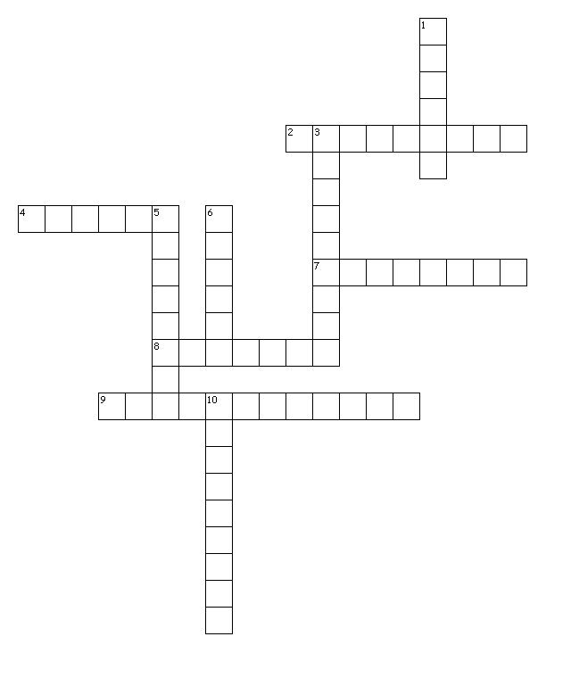

Across
2. the way an organism looks
4. the offspring of two different pure lines
7. the combination of alleles than an organism inherits for a certain trait
8. alternate forms of a gene
9. one dominant and one recessive allele
Down
1. inherited characteristics transmitted from one generation to the next
3. 2 identical alleles
5. a trait that prevents a recessive trait from showing
6. father of genetics
10. a trait that is hidden by a dominant trait

U | L | I | J | L | E | D | B | S | J | X | Q | Q | T | D
P | J | K | Q | R | D | E | I | U | V | L | L | F | I | O
N | Q | V | J | I | S | Y | W | O | E | C | I | J | C | M
P | I | G | H | O | M | Z | Y | G | O | U | S | Y | E | I
T | Z | C | K | P | D | D | S | Y | K | G | G | V | N | N
P | X | D | U | L | I | O | G | Z | G | P | I | S | Y | A
V | H | Y | B | R | C | E | Z | O | A | S | J | W | A | N
L | X | E | B | A | N | D | P | R | S | J | H | S | Q | T
J | E | Y | N | O | S | E | L | E | L | L | A | T | G | E
Q | H | D | T | O | V | Z | C | T | A | H | I | I | G | G
V | L | Y | N | D | T | E | F | E | L | N | H | A | K | U
Q | P | O | B | E | R | Y | S | H | M | P | R | R | Y | T
E | Z | B | K | V | M | M | P | M | O | N | O | T | F | X
C | B | D | D | T | J | S | B | E | B | O | H | C | U | Z
L | X | D | Y | Q | E | X | W | I | Z | E | K | B | Y | A

ALLELES | DOMINANT | GENOTYPE
HETEROZYGOUS | HOMZYGOUS | HYBRID
MENDEL | PHENOTYPE | RECESSIVE
TRAITS

TtGg x TTgg

Find the genotype and the phenotype

Patterns of Inheritance
