Genetics Lesson 2
Patterns of Inheritance

Quiz Date:

Vocabulary

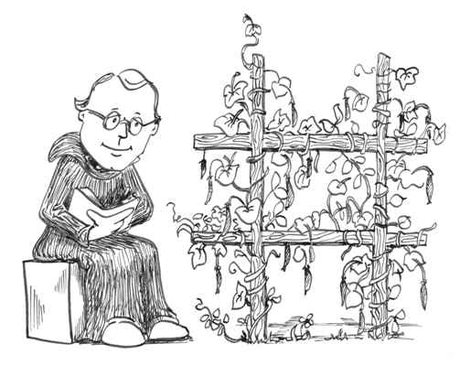

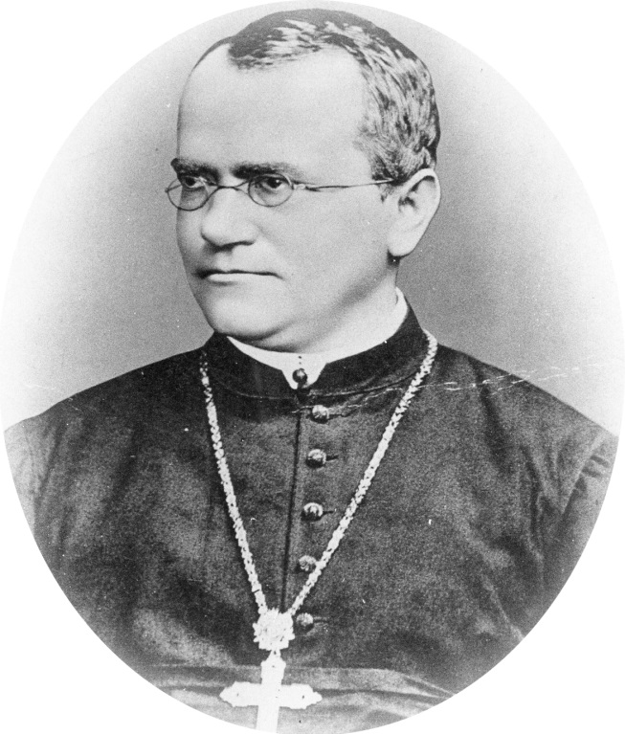
Gregor Mendel
- Gregor Mendel-1800’s, Austrian monk in Czechoslovakia, he was the first scientist to describe patterns of inheritance
- Mendel studied pea plants, over 7 years he studied over 30,000 individual plants
Mendel’s Hybrid Peas
- Traits-inherited characteristics transmitted from one generation to the next
- Gametes-reproductive cells that carry genetic information
- Fertilization-when information for one gamete is combined with another gamete
Why did Mendel use pea plants for his experiments?
- Mendel studied inheritance using pea plants
- The flowers of pea plants has both male and female reproductive parts
- Every flower can produce male gametes called sperm and female gametes called eggs
- Because the flowers of pea plants have both kinds of gametes, the plants are capable of self-fertilization
- It was also possible for Mendel to cross fertilize plants
- As a result he could breed different plants in a controlled way
- Mendel bred plants that were distinctive for particular traits
- For example he obtained tall pea plants and bred them form many generations
What is a hybrid?
- He noticed that tall pea plants produced seeds that grew into tall plants
- Likewise, short plants always produced seeds that grew into short plants
- Tall and short plants were two distinct varieties or pure lines
- All self-fertilized offspring of pure lines display the same trait as their parents
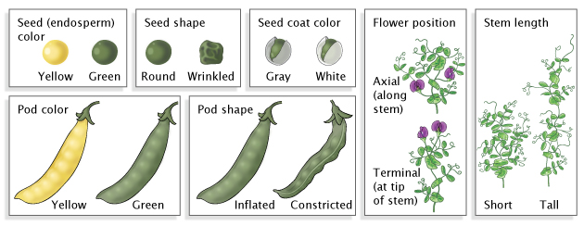
- When parents of two different pure lines are crossed, the offspring are called hybrids
Mendel’s Experiment
- Mendel studied 7 contrasting characteristics
Mendel and Plant Height
- Mendel began by crossing pure lines of tall plants and pure lines of short plants
What happened when Mendel crossed a short plant with a tall plant in the first generation?
- He named this generation the parental generation or the P1 generation
- All of the offspring were tall, Mendel called this generation the F1 generation
  - the F stands for filial which means “of an offspring”
- The trait for shortness seemed to have disappeared
- Mendel then produced the next generation by self-fertilization
- He called this generation the F2 generation
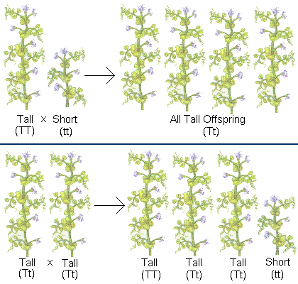
- Not all of the F2 generation were tall, one out of every four offspring were short
Dominant and Recessive Traits
- Mendel concluded that distinct units of heredity, or factors, were responsible for the inherited traits
- He also thought that two factors controlled any single trait
- For example, one factor produced tall plants and one produced short plants
- In the F1 plants, the tall factor appeared to be dominant over the short factor
- Dominant-a trait that prevents a recessive trait from showing
Why did the short trait disappear in the first generation?

- In the F2 generation the hidden, or recessive trait reappeared
- Recessive-a trait that is hidden by a dominant trait
- The recessive factor seemed to recede into the background in the presence of the dominant gene
- After crossing plants for other traits, such as seed color and seed texture, Mendel identified one factor in each pair as dominant and the other as recessive
- In all of those crosses, only the dominant trait appeared in the F1 generation
- The recessive trait always reappeared in the F2 generation

Principle of Segregation
Why did Mendel get a 3:1 ratio in the F2 generation?
- Not only did the recessive traits appear in the F2 generation, but they reappeared in a constant proportion or ratio
- Three fourths of the plants showed the dominant trait and one fourth showed the recessive trait
- For any pair of contrasting traits, Mendel always got a 3:1 ratio in the F2 generation
- Mendel proposed a principle that explained the 3:1 ratio he observed and predicted the ratios for other crosses
Principle of Segregation
- Hereditary characteristics are determined by distinct units or factors
- For each characteristic, an individual carries two factors, one inherited from each parent
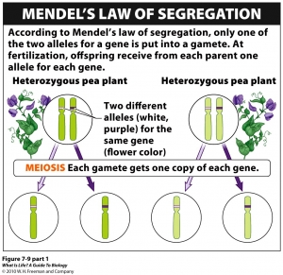
- The two factors of each pair segregate from each other and end up in separate gametes
- Today these factors are called genes
- Alleles-alternate forms of a gene
- For example, an gene controls the seed color of peas
- One allele of that gene produces green seeds and the other allele produces yellow seeds
- Only one allele for each trait is passed on to the offspring of each parent
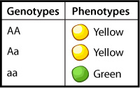
Genotype and Phenotype
- A dominant allele is indicated by a capitol letter, the matching recessive allele is indicated by the same letter only lower case
- Different letters are used for different traits
Plant height
T=tall dominant
t=short recessive
- An organism inherits two alleles for each trait—one from each parent
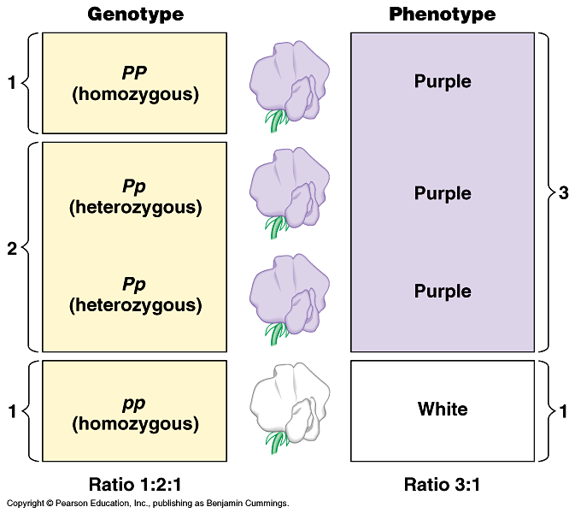
- Therefore two letters are needed to describe each combination of alleles
- Genotype-the combination of two alleles that an organism inherits for a certain trait
- If a pea plant inherits an allele for tallness from each parent, the genotype of the pea plant would be TT
- A pea plant with the genotype tt has two alleles for shortness
- A pea plant with the genotype Tt has an allele of each type
- Homozygous-2 identical alleles, either both dominant or both recessive. Ex. TT or tt
- Heterozygous-one dominant allele and one recessive allele. Ex. Tt
- An organism’s genotype determines how a trait will be expressed
- A genotype of TT will be tall because T is dominant
What does probability mean?
- A genotype of Tt will be tall because tallness is dominant and it will keep the recessive trait from showing
- The way an organism looks is its phenotype
- The phenotype doesn’t’ always reveal the genotype; organisms with the same phenotype for tall will not necessarily have the same genotype, TT or Tt
Solving Genetic Problems
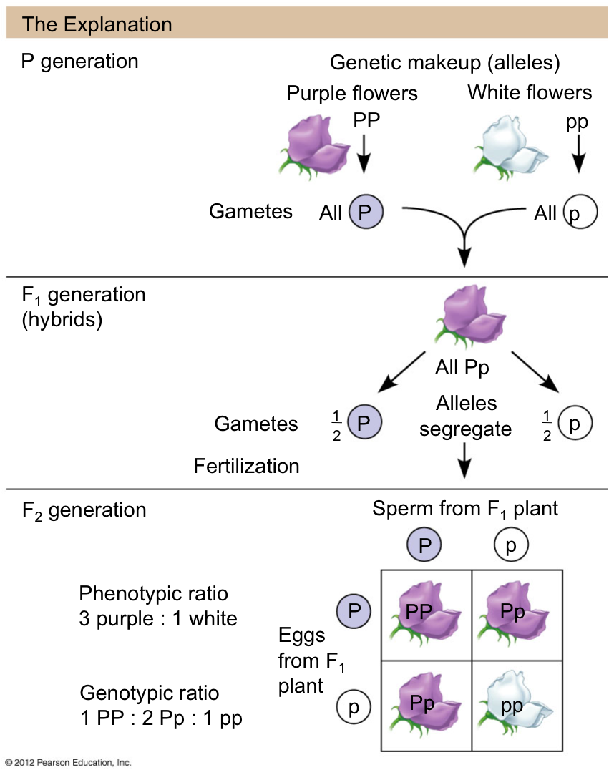
- If you know the genotype of the parents, it is possible to predict the likelihood of an offspring inheriting a particular phenotype
- We can find the probability or ratio of possible offspring phenotypes
- In a cross between parents who have the genotypes TT and tt each parent can only contribute one allele of a trait
- The tall parent can only contribute one T and the short parent can only contribute one t (principle of segregation)
- The genotype of the offspring are a combination of gametes from both parents
- All of the offspring will have the genotype Tt and will have the phenotype tall because T is dominant over t

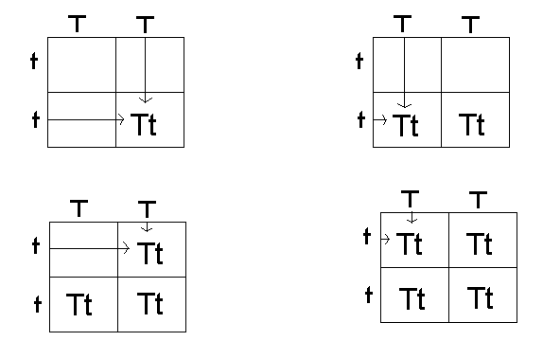
Punnett Square
- Punnett square- a chart that shows all of the possible genotypes of a cross

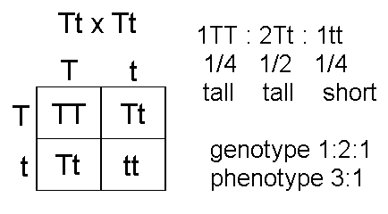

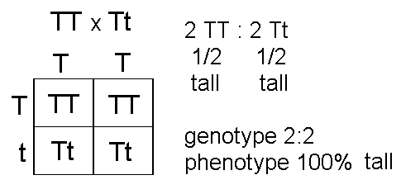

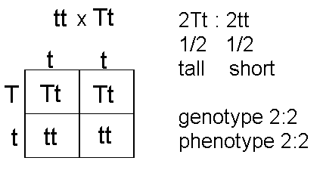

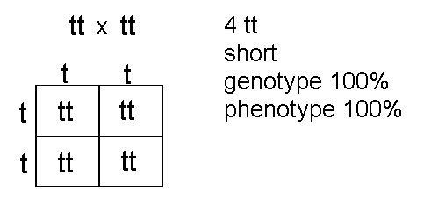

Test Cross
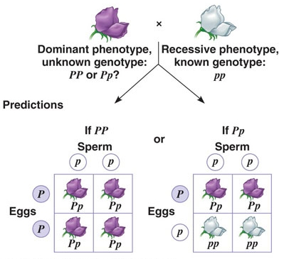
- You know the genotype of a short plant is tt because any other combination would result in a tall plant
- To determine the genotype of a tall plants we do a test cross
- A test cross crosses an unknown genotype with a known genotype
- A tall plant can have the genotype TT or Tt, by crossing it with the homozygous recessive (short plant) we can determine the genotype of the tall plant
- If the unknown plant was TT, crossing it with tt will result in a genotypes being Tt
- If the unknown plant was Tt, crossing it with tt will result in 50% Tt and 50% tt
Principle of Independent Assortment
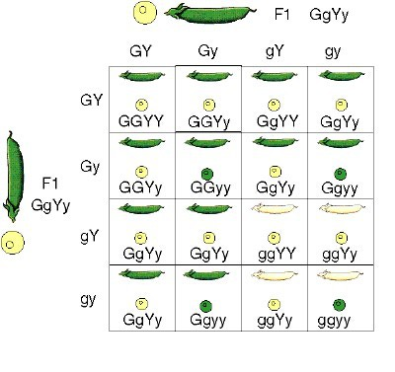
- It is possible to study the inheritance of two traits at the same time
- Dihybrid cross-a genetic cross involving two traits or alleles
- Principle of Independent Assortment-the inheritance of alleles for one trait does not affect the inheritance of alleles for another trait
- Whether a plant is tall or short does not affect whether its seeds are smooth or wrinkled
- To test the principle of independent assortment, Mendel crossed plants that were homozygous dominant for height and pod color (TT and GG) with plants that were homozygous recessive for height and pod color
- Remember each parent can only contribute one allele for each trait
- One parent contributes tall and green the other short and yellow
- All offspring of this cross will be heterozygous and be tall with green pods
F.O.I.L
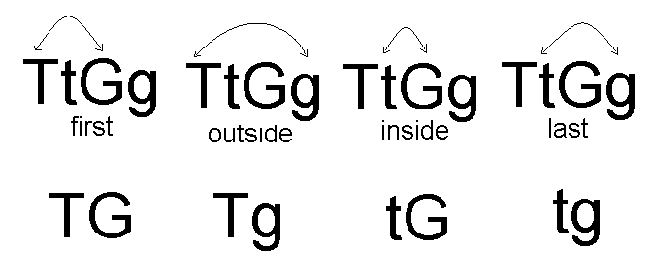

Dihybrid Cross

