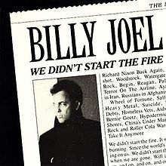
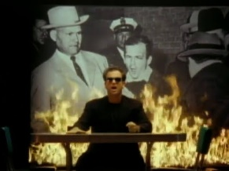
“We Didn’t Start The Fire” Personal Song

You will be creating a personal version of “We Didn’t Start the Fire.” Billy Joel wrote this song, one line for each year of his life. You will be doing the same! You will research at least 4 events, people, or cultural aspects (movies, songs, celebrities etc.) from each year you were born and create your own version of the song. You will have one line for every year of your life starting with the year you were born and going all the way to THIS YEAR! You must have at least one historical event in each line. An example of this will be shown in class. It DOES NOT have to rhyme, but you should make an effort to make it fun!
Due Date:______________________
Worth 50 points – Graded on completion of 4 events/people per line, one historical event per line, and the accuracy of the dates.
Some of you will be presenting to the class. Remember, it does not have to rhyme, but you definitely can make it rhyme like Billy Joel did!

“We Didn’t Start The Fire” Personal Song

You will be creating a personal version of “We Didn’t Start the Fire.” Billy Joel wrote this song, one line for each year of his life. You will be doing the same! You will research at least 4 events, people, or cultural aspects (movies, songs, celebrities etc.) from each year you were born and create your own version of the song. You will have one line for every year of your life starting with the year you were born and going all the way to THIS YEAR! You must have at least one historical event in each line. An example of this will be shown in class. It DOES NOT have to rhyme, but you should make an effort to make it fun!
Due Date:______________________
Worth 50 points – Graded on completion of 4 events/people per line, one historical event per line, and the accuracy of the dates.
Some of you will be presenting to the class. Remember, it does not have to rhyme, but you definitely can make it rhyme like Billy Joel did!

