Name__________________________________________

Planets

Due Date:

Reading __________________
Guide __________________
Review __________________
Critical Thinking __________________
Concept Map __________________
Crossword __________________
Test Prep __________________

Planets Reading
- Astronomical unit
- Light minute
- Terrestrial planet
- Mercury
- Rotation
- Period or rotation
- Orbits
- Period of revolution
- Venus
- Prograde rotation
- Retrograde rotation
- Earth
- Mars
- Olympus Mons
- Gas giants
- Jupiter
- Saturn
- Rings
- Uranus
- William Herschel
- Neptune
- Pluto
Planets Guide
Astronomical unit

Terrestrial planets

Prograde rotation

Retrograde rotation

Gas giants

Give the distance from the sun, the period of rotation and period of revolution for each planet.
Mercury

Venus

Earth

Mars

Jupiter

Saturn

Uranus

Neptune

Pluto (not a planet)

Planets Review
Earth Mercury retrograde rotation Venus
gas giants Neptune Saturn
Jupiter Pluto terrestrial planets
Mars prograde rotation Uranus

- __________________________________________ are the small, dense, rocky planets of the inner solar system.
- The counterclockwise spin of a planet or moon as seen from the planets north pole is ______________________________________________________.
- The clockwise spin of a planet or moon as seen from above the planet's north pole is ______________________________________________________.
- The _____________________________________________ are the large, planets of the outer solar system.
- ______________________________ is the first terrestrial planet from the sun, smallest planet.
- The fifth gas giant from the sun, largest planet, made of hydrogen and helium is _________________________________.
- The third terrestrial planet from the sun; has liquid water is ______________________.
- ____________________________________________ is the second terrestrial planet from the sun, retrograde motion, hottest planet.
- The fourth terrestrial planet from the sun, thin atmosphere, largest volcano is ________________________________.
- The sixth gas giant from the sun, largest rings, most moons is __________________________.
- The 7th gas giant from the sun, rotates sideways, first to be discovered with a microscope is ______________________________________.
- ___________________________________ is the planet-like object beyond Neptune, made of rock and ice.
- The 8th gas giant from the sun, many clouds is ____________________________________.
Identify the planets as being either terrestrial (T) or gas giant (G).
- _____Neptune
- _____Earth
- _____Saturn
- _____Jupiter
- _____Venus
- _____Uranus
- _____Mercury
- _____Mars
Determine whether the statement is true (T) or false (F).
- _____Mercury rotates slower than Earth.
- _____The most similar planet to Earth is Mars.
- _____Mars and Earth are the only planets with liquid water.
- _____Jupiter is made mostly of hydrogen and helium.
- _____Years get shorter as we move away from the sun.
- _____Uranus is tipped on its side.

Put the planets in order from smallest to largest. Use numbers.
- _____Mercury
- _____Venus
- _____Earth
- _____Mars
- _____Jupiter
- _____Saturn
- _____Uranus
- _____Neptune

- Most planets spin counter clockwise on their axis. This is
  - Prograde rotation
  - Prograde revolution
  - Retrograde rotation
  - Retrograde revolution

- Which of these planets does not have any moons?
  - Mercury
  - Uranus
  - Mars
  - None of the above

- Liquid water cannot exist on the surface of Mars because
  - The temperature is too hot
  - Liquid water once existed there
  - The gravity of Mars is too weak
  - The atmospheric pressure is too low

- Which of the following planets is not a terrestrial planet?
  - Mercury
  - Mars
  - Earth
  - Pluto

- Which of the following planets has rings?
  - Mercury
  - Pluto
  - Venus
  - Uranus

- This planet has retrograde rotation.
  - Mars
  - Mercury
  - Uranus
  - Venus

- This planet has days that are longer than its years.
  - Mercury
  - Uranus
  - Venus
  - Jupiter

- This planet rotates on its side.
  - Jupiter
  - Saturn
  - Venus
  - Uranus

- The planet with the shortest year is
  - Mercury
  - Neptune
  - Pluto
  - Mars

- The planet with the longest year is
  - Mercury
  - Neptune
  - Jupiter
  - Saturn

- All of the gas giants have
  - Moons
  - Rings
  - Volcanoes
  - Both a and b

Planets Critical Thinking
- What three characteristics do the inner planets have in common?

- List three similarities between Venus and Earth.

- Why is Venus hotter than Mercury?

- What is unusual about Uranus’s axis of rotation?

- Why is the word surface not included in the statistics for the gas giants?

- Why is Saturn less colorful than Jupiter?

- What are rings?

- What are three differences between gas giants and terrestrial planets?

- What does Earth have that the other planets don’t that makes life possible?

- Why is a day on Venus longer than a year on Venus?

Planets Concept Map
Use the following terms to create a concept map: largest planet, Mercury, liquid water, Jupiter, retrograde motion, Venus, planet, terrestrial, axis on its side, Saturn, biggest volcano, Earth, gas giant, Uranus, most rings, Mars, smallest planet, farthest from sun, Neptune.

- The gas giants have many more moons than the terrestrial planets. Explain why this is so? (the answer may not be in your notes)

- What is one explanation for Uranus being on it’s side?

- What happens to the length of a year as planets get farther from the sun? Explain.

- Why is it unlikely that we will find life on Mars?

- What do the eight planets have in common? Hint: what makes them planets?

Planets
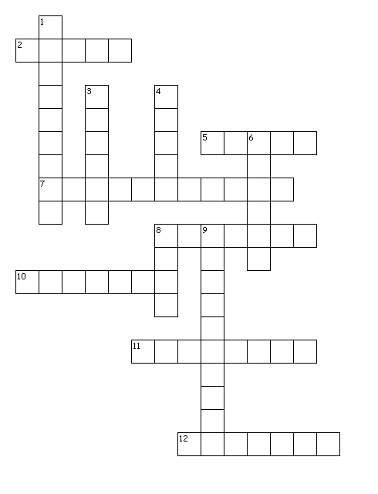
Across
2. third terrestrial planet from the sun, liquid water
5. planet-like object beyond Neptune, made of rock and ice
7. small, dense, rocky planets of the inner solar system
8. first terrestrial planet from the sun, smallest planet
10. fifth gas giant from the sun, largest planet, made of hydrogen and helium
11. the counterclockwise spin of a planet or moon as seen from the planets north pole
12. 8th gas giant from the sun, many clouds
Down
1. the large, gaseous planets of the outer solar system
3. sixth gas giant from the sun, largest rings, most moons
4. second terrestrial planet from the sun, retrograde motion, hottest planet
6. 7th gas giant from the sun, rotates sideways, first to be discovered with a microscope
8. fourth terrestrial planet from the sun, thin atmosphere, largest volcano
9. the clockwise spin of a planet or moon as seen from above the planet's north pole

S | P | L | U | T | O | M | R | M | H | P | B | C | O | N | N | J | O | N | X
S | T | K | J | J | D | B | A | T | S | Q | Q | W | E | O | P | U | M | O | Z
U | U | E | I | Z | M | G | R | R | Y | F | Y | P | I | Q | T | P | D | I | G
U | K | N | N | A | K | A | F | W | S | Z | T | T | X | A | W | I | U | T | C
Q | P | B | A | A | E | C | I | N | L | U | A | S | H | N | I | T | U | A | P
J | L | N | B | R | L | G | I | N | N | T | N | U | G | O | C | E | A | T | A
C | F | X | U | M | U | P | D | E | O | A | B | A | Q | H | C | R | S | O | V
A | F | K | B | F | G | Q | L | R | M | N | R | U | T | A | S | N | U | R | I
M | R | N | G | K | Y | P | E | A | R | E | H | Y | B | J | I | B | N | E | J
K | I | V | Z | D | T | D | A | G | I | Y | R | R | K | V | N | I | E | D | K
G | A | S | G | I | A | N | T | S | B | R | J | C | Q | J | U | J | V | A | C
U | M | W | A | R | U | I | X | V | G | U | T | K | U | S | M | M | F | R | P
X | D | X | G | F | L | R | X | L | K | C | B | S | C | R | N | X | H | G | P
J | H | O | P | L | V | K | F | F | Z | T | A | N | E | E | Y | C | I | O | S
K | R | K | V | C | S | D | T | I | H | H | B | I | J | R | L | S | K | R | B
P | T | V | D | V | S | H | Y | G | D | Z | C | H | W | U | R | D | D | T | R
P | J | R | N | U | T | X | B | W | X | R | F | F | O | U | F | E | N | E | Y
D | V | V | U | K | S | K | K | P | F | Q | V | J | G | A | O | W | T | R | O
P | K | S | E | T | L | K | Z | X | L | M | X | S | I | W | Y | P | E | D | Q
C | F | Q | U | B | B | C | O | P | L | G | I | N | Y | E | O | A | C | B | F

EARTH | GASGIANTS | JUPITER
MARS | MERCURY | NEPTUNE
PLUTO | PROGRADEROTATION | RETROGRADEROTATION
SATURN | TERRESTRIALPLANETS | URANUS VENUS

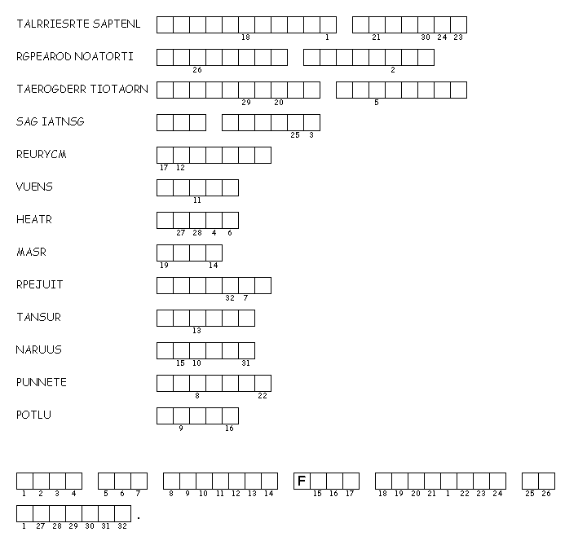

Test Prep
26) When elements form mixtures, the elements
A) keep their original properties.
B) react to form a new substance with new properties.
C) combine in a specific mass ratio.
D) always change their physical state.

27) Which of the following is NOT true of compounds?
A) The unique set of properties of a compound differ from the properties of the elements that
make up the compound.
B) The particles are made of atoms of two or more elements that are chemically combined.
C) Different samples of any compound have the same elements in the
same proportion.
D) They can be separated by physical methods.

28) How is a mixture different from a compound?
A) Mixtures have two or more components.
B) Each substance in a mixture keeps its characteristic properties.
C) Mixtures are commonly found in nature.
D) Solids, liquids, and gases can form mixtures.

29) During what type of reaction do the atoms of two or more elements join together
to form compounds?
A) reaction with acid
B) physical reaction
C) chemical reaction
D) chain reaction

30) When materials combine to form a mixture, they
A) keep their original properties.
B) react to form a new substance with new properties.
C) combine in a specific ratio.
D) always change their physical state.

