Name__________________________________________

Solar System

Due Date:

Reading __________________
Guide __________________
Review __________________
Critical Thinking __________________
Concept Map __________________
Crossword __________________
Test Prep __________________

Solar System Reading
- Solar system
- Nebula
- Mass
- Temperature
- Solar nebula
- Planetesimals
- Giant gas planets
- Rocky planets
- Comet
- Rotation
- Orbit
- Revolution
- Period of revolution
- Kepler’s first law of motion
- Ellipse
- Semi major axis
- Astronomical unit
- Kepler’s second law of motion
- Kepler’s third law of motion
- gravity

Solar System Guide
Solar system.

Nebula

Solar nebula

Planetesimals

Gas giants

Orbit

Revolution

Period of revolution

Ellipse

Astronomical unit

Solar System Review
Astronomical unit Orbit revolution solar nebula
Ellipse period of revolution rotation solar system
Nebula planetesimals

- The ______________________________________________ composed of the sun and planets and other bodies that travel around the sun.
- ____________________________________ happens when Earth spins on its axis.
- An ___________________________________ is an enclosed curve in which the sum of the distances from the edge of the curve to two points inside the ellipse is always the same.
- Dust and gas together in huge interstellar clouds form _________________________________.
- _______________________________________________ is the name of the nebula that formed into our solar system.
- ____________________________________ are the building blocks of planets.
- The amount of time it takes for a single trip around the sun is the _____________________
_______________________________________.
- The path around the sun is an _________________________.
- _________________________________________ is motion around the sun along its orbit.
- An __________________________________________________ is the average distance between the Earth and the sun.

- _____measure of the amount of matter a. pressure
- _____measure of how fast particles are moving b. mass
- _____the amount of force exhorted on a given area c. temperature

- _____determines day and night a. period of revolution
- _____determines a year b. rotation
- _____moving around the sun c. orbit
- _____path around the sun d. revolution

Determine whether the statements are true (T) or false (F).
- _____Kepler’s first law states that planets move around the sun in a circle.
- _____Kepler’s second law states that planets move slower when they are closer to the sun.
- _____Kepler’s third law states that the distance from the sun can be calculated using the period of revolution.
- _____Planets move faster when they are closer to the sun because of gravity.
- _____Planetesimals always become planets.
- _____An elliptical path is a circle.

- _____________________________ is the spinning of a body on its axis. (rotation or revolution)

- ______________________________ is the movement of a smaller body around a larger body. (rotation or revolution)
- The __________________________________ is composed of the sun, its planets and other bodies in orbit around the sun. (solar system or solar nebula)
- The _______________________________________ was an interstellar cloud of gas and dust that formed the sun and planets. (solar system or solar nebula)
- _________________________________________ make _____________________________. (planets and planetesimals)
- __________________________________________ is the measure of how fast particles in an object move around. (pressure or temperature)
- An astronomical unit is the
  - Average distance between Earth and the moon
  - Average distance between planets
  - Average distance between stars
  - Average distance between Earth and the sun

- Planets in the solar system travel in a(n)
  - Circle
  - Ellipse
  - Nebula
  - Oval

- The time it takes a planet to make one complete orbit.
  - Period of revolution
  - Period of rotation
  - Period of orbit
  - Period of ellipse

- The elliptical motion of a body as it orbits another body in space.
  - Rotation
  - Orbit
  - Ellipse
  - Revolution

- The spinning motion of a body on its axis.
  - Orbit
  - Revolution
  - Period of revolution
  - Rotation

- Tiny building blocks of planets.
  - Planetesimals
  - Mini planets
  - Asteroids
  - Meteoroids

- The solar nebula is the
  - Nebula that made our solar system
  - Nebula that made our sun
  - Nebula that made our planets
  - All of the above

- Stars are formed from
  - Nebulas
  - Pressure
  - Gravity
  - All of the above

- Planets follow a curved path called an ellipse.
  - Kepler’s First Law
  - Kepler’s Second Law
  - Kepler’s Third Law
  - Newton’s Universal Law of Gravitation

- Planets move faster when they are closer to the sun.
  - Kepler’s First Law
  - Kepler’s Second Law
  - Kepler’s Third Law
  - Newton’s Universal Law of Gravitation

- When we know a planet’s period of revolution we can calculate the planet’s distance from the sun.
  - Kepler’s First Law
  - Kepler’s Second Law
  - Kepler’s Third Law
  - Newton’s Universal Law of Gravitation

- The force of gravity depends on the mass of the objects and the distance between them.
  - Kepler’s First Law
  - Kepler’s Second Law
  - Kepler’s Third Law
  - Newton’s Universal Law of Gravitation

- What is the term for the speed of gas molecules?
  - Temperature
  - Pressure
  - Gravity
  - Force
Solar System Critical Thinking
- What two forces balance each other to keep a nebula of dust and gas from collapsing or flying apart?

- Why does the composition of the giant gas planets differ from that of the rocky inner planets?

- Explain why there is only one planet in each orbit around the sun.

- On what properties does the force of gravity between two objects depend?

- Will a planet be moving faster in its orbit when it is farther from or closer to the sun? Explain.

- How does gravity keep a planet moving in an orbit around the sun?

- Why did the solar nebula begin to collapse to form the sun and planets if the forces of pressure and gravity are balanced?

- How is the period of revolution related to the semi major axis of an orbit? Draw an ellipse and label the semi major axis.

- Suppose a certain planet had two moons, one of which was twice as far from the planet as the other. Which moon would complete one revolution of the planet first? Explain.

- Why do all of the planets go around the sun in the same direction and why do the planets all lie in a flat plane?

Solar System Concept
Use the following terms to create a concept map: 1st Law, Kepler’s Laws of Motion, 2nd Law, ellipse, planets faster closer to sun, period of revolution and distance, 3rd Law

Use the following terms to create a concept map: rotation, years, revolution, days, orbit, planetary motion, path around sun,

- Put the steps of solar system formation in order, use numbers.
_____planetesimals begin to form within the swirling disk
_____the young solar nebula begins to collapse because of gravity
_____the largest planetesimals begin to sweep up more and more dust and gas
_____the remaining dust and gas are gradually removed from the solar nebula, leaving planets
around the sun
_____smaller planetesimals collide with the larger ones, planets begin to grow
_____the solar nebula begins to rotate, flatten and get warmer near its center

Solar System
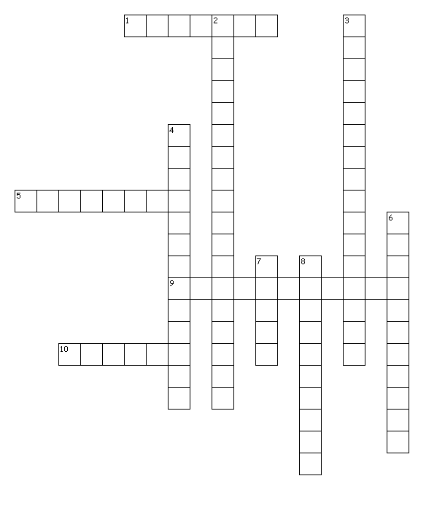
Across
1. an enclosed curve in which the sum of the distances from the edge of the curve to two points inside the ellipse is always the same
5. Earth spins on its axis
9. the name of the nebula that formed into our solar system.
10. dust and gas together in huge interstellar clouds
Down
2. the amount of time it takes for a single trip around the sun
3. the average distance between the Earth and the sun
4. building blocks of planets
6. composed of the sun and planets and other bodies that travel around the sun
7. path around the sun
8. motion around the sun along its orbit
N | J | O | M | X | V | V | B | I | Q | O | O | T | S | R | K | Z | G | I | J
P | O | E | S | D | H | Z | U | Q | F | H | D | L | B | E | S | P | T | W | B
D | C | I | E | O | U | M | V | Y | X | Z | A | F | N | V | F | N | I | M | D
F | V | T | T | H | L | H | H | Q | U | M | O | Q | G | O | F | R | N | J | C
A | W | I | T | U | L | A | T | E | I | W | Z | R | H | L | F | M | U | Z | G
A | L | B | S | O | L | A | R | S | Y | S | T | E | M | U | D | D | L | M | M
W | K | U | Q | O | J | O | E | N | Z | W | E | V | W | T | O | H | A | F | T
Y | G | G | B | A | G | T | V | R | E | K | T | V | C | I | Y | A | C | U | F
W | S | M | E | E | E | M | O | E | W | B | K | P | V | O | B | H | I | R | P
B | N | O | F | N | N | T | L | V | R | N | U | C | T | N | D | W | M | H | S
A | M | H | A | R | A | U | J | A | L | F | Q | L | P | J | J | E | O | M | Q
K | X | L | U | T | G | X | P | R | D | B | O | X | A | G | T | H | N | N | B
U | P | C | I | T | E | C | D | Z | D | T | S | D | W | A | P | W | O | J | Q
N | D | O | Y | I | F | B | U | K | Y | D | D | Q | O | L | Z | T | R | V | B
B | N | C | K | B | T | S | F | X | S | R | B | M | A | I | Y | P | T | Y | R
A | M | F | R | R | G | V | O | M | H | K | R | V | K | W | R | K | S | Q | E
H | F | D | D | O | D | P | L | J | H | V | C | K | F | C | G | E | A | I | V
R | P | C | B | M | C | K | C | S | L | I | Q | D | D | R | O | A | P | T | D
E | S | P | I | L | L | E | P | Z | F | E | M | L | Q | U | J | W | P | I | Y
M | L | C | C | T | S | I | H | S | O | V | Y | N | V | C | J | A | M | E | D

Solar System

ASTRONOMICALUNIT | ELLIPSE | NEBULA
ORBIT | PERIODOFREVOLUTION | PLANETESIMALS
REVOLUTION | ROTATION | SOLARNEBULA
SOLARSYSTEM

Solar System
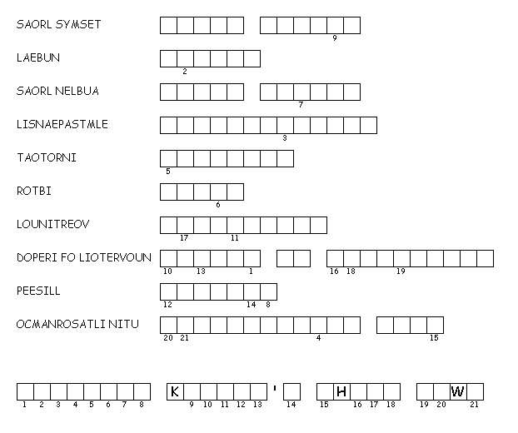

Test Prep
21) If a spoonful of salt is mixed in a glass of water, what is the water called?
A) a solute
B) a solution
C) a solvent
D) an element
22) An element contains only one kind of
A) particle.
B) property.
C) protein.
D) raw material.

23) What is formed when particles of two or more substances are distributed evenly
among each other?
A) a compound
B) solubility
C) a solution
D) an element

24) How is a compound different from a mixture?
A) Compounds have two or more components.
B) Each substance in a compound loses its characteristic properties.
C) Compounds are commonly found in nature.
D) Solids, liquids, and gases can form compounds.

25) The particles in a solution
A) cannot scatter light.
B) can settle out.
C) are insoluble.
D) can pass through a fine filter.

