Name__________________________________________

Stars

Due Date:

Reading __________________
Guide __________________
Review __________________
Critical Thinking __________________
Concept Map __________________
Crossword __________________
Test Prep __________________

Name_____________________________________________________ Score________
Stars Reading
- spectrum
- apparent magnitude
- absolute magnitude
- light year
- parallax
- H-R diagram
- main sequence
- white dwarf
- red giant
- supernova
- neutron star
- pulsar
- black hole

Stars Guide
Spectrum

Apparent magnitude

Absolute magnitude

Light-year

Parallax

H-R diagram

Main sequence

White dwarf

Red giant

Supernova

Neutron star

Pulsar

Black hole

Stars Review
spectrum H-R diagram white dwarf neutron star
apparent magnitude parallax red giant pulsar
absolute magnitude light year supernova black hole
main sequence
- _________________________________________________ is the rainbow of colors produced when white light passes through a prism or spectrograph.
- A __________________________________________________ is an object with more than three solar masses squeezed into a ball only 10 km across whose gravity is so strong that not even light can escape.
- __________________________________________________________ is how bright a light appears to an observer.
- __________________________________________________________ is the unit of length equal to the distance that light travels in space in one year.
- A ____________________________________________________________ is a small, hot star near the end of its life; the leftover center of an old star.
- _____________________________________ is an apparent shift in the position of an object when viewed from different positions.
- A _____________________________________________ is a graph that shows the relationship between a star's surface temperature and its absolute magnitude.
- The _____________________________________________________ is a diagonal pattern of stars on the H-R diagram.
- The actual brightness of a star is ___________________________________________________.
- A star that expands and cools once it runs out of hydrogen fuel is a _______________________.
- A _________________________________________________ is the death of a large star by explosion.
- A ______________________________________________ is a spinning neutron star that emits rapid pulses of light.
- A star in which all the particles have become neutrons; collapsed remains of a supernova is a ______________________________________________.
Put the life cycle of stars in order from youngest to oldest. Use numbers.
- _____red giant
- _____white dwarf
- _____supernova

Determine whether the statement is true (T) or false (F).
- _____On an H-R diagram, hot blue stars are on the left.
- _____Neutron stars are formed after a supernova.
- _____A black hole is black because light cannot escape.
- _____Most stars are main sequence stars.
- _____Stars closer to Earth appear to move, while stars farther away appear stationary.

- Which is brighter, a 1st magnitude star or a 6th magnitude star?
  - 1st magnitude
  - 6th magnitude

Which of the following form after a supernova? S for supernova and O for other.
- _____white dwarf
- _____pulsar
- _____red giant
- _____neutron star
- _____black hole

- _____left over core of a small star. a. black hole
- _____left over core of a massive star. b. main sequence
- _____star that is stable. c. white dwarf
- _____fusion stopped, outer layers expanded. d. red giant

- The rainbow of colors produced when white light passes through a prism or spectrograph is __________________________________________________. (spectrum or parallax)
- How bright a light appears to an observer is its _______________________________________. (apparent magnitude or absolute magnitude)
- An apparent shift in the position of an object when viewed from different positions is _______________________________________________. (parallax or main sequence)
- A graph that shows the relationship between a star’s surface temperature and it’s absolute magnitude is a ____________________________________________. (main sequence or H-R diagram)

- A cluster of stars forms in a nebula. There are red stars, blue stars, yellow stars and white stars. Which stars are most like the sun?
  - Red
  - Yellow
  - Blue
  - White

- The majority of stars in our galaxy are
  - Blue
  - White dwarfs
  - Main-sequence stars
  - Red giants

- A star that expands and cools once it runs out of hydrogen fuel is a
  - White dwarf
  - Red giant
  - Neutron star
  - pulsar

- Where is Earth located on the H-R diagram?
  - On the upper left
  - On the upper right
  - On the main sequence
  - On the lower right

- A small hot star near the end of its life; the left over center of an old star is a
  - White dwarf
  - Red giant
  - Neutron star
  - Pulsar

- The death of a large star by explosion.
  - Main sequence
  - Black hole
  - Supernova
  - Pulsar

- What information does the H-R diagram give us?
  - Temperature
  - Brightness
  - Stage of life cycle
  - All of the above

- How is a neutron star related to a pulsar?
  - A pulsar is a spinning neutron star
  - A neutron star is a spinning pulsar
  - A pulsar is the compressed core of a neutron star
  - Pulsars make neutron stars
- How is the distance from Earth to a star measured?
  - Parallax
  - Trigonometry
  - Spectrograph
  - Both a and b

- How are stars classified?
  - By what they are made of
  - By size
  - By temperature
  - By age

- Which star is hottest?
  - Blue
  - Yellow
  - Red
  - Orange

Stars Critical Thinking
For each pair of terms, explain the difference in their meanings.
- Absolute magnitude/apparent magnitude

- Spectrum/parallax

- Neutron star/pulsar

- What are black holes and how are they formed?

- What is the H-R diagram and what does it tell us?

- What is a supernova?

- Are blue stars young or old? How can you tell?

- In main-sequence stars, what is the relationship between brightness and temperature?

- Describe how the apparent magnitude of a star varies with its distance from Earth.

- If a certain star displayed a large parallax, what could you say about its distance from Earth?

Stars Concept Map
Use the following terms to create a concept map: white dwarf, emits light, red giant, stars, end of life, neutron star, pulsar, very dense, out of hydrogen.

- What kind of star is our sun?

- How are stars classified?

- What is the difference between apparent magnitude and absolute magnitude?

- Is a yellow star, such as the sun, hotter or cooler than and an orange star? Explain.

- What is a supernova? What can they make?

Stars
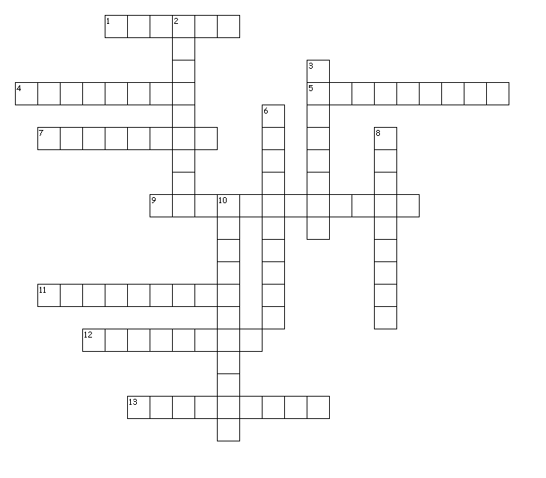
Across
1. a spinning neutron star that emits rapid pulses of light
4. the actual brightness of a star
5. an apparent shift in the position of an object when viewed from different positions
7. a star that expands and cools once it runs out of hydrogen fuel
9. a diagonal pattern of stars on the H-R diagram
11. a unit of length equal to the distance that light travels in space in one year
12. how bright a light appears to an observer
13. a graph that shows the relationship between a star's surface temperature and its absolute magnitude
Down
2. the death of a large star by explosion
3. the rainbow of colors produced when white light passes through a prism or spectrograph
6. a small, hot star near the end of its life; the leftover center of an old star.
8. an object with more than three solar masses squeezed into a ball only 10 km across whose gravity is so strong that not even light can escape
10. a star in which all the particles have become neutrons; collapsed remains of a supernova

E | D | U | T | I | N | G | A | M | E | T | U | L | O | S | B | A | F | L | T
R | C | O | U | M | O | E | K | S | L | G | K | J | Y | Q | S | R | L | H | N
A | X | N | Q | U | Y | M | U | Z | K | I | T | Q | L | G | A | G | C | R | E
J | Y | B | E | G | N | P | W | J | N | L | G | A | K | W | F | D | Z | D | R
R | A | G | G | U | E | E | X | U | M | M | E | H | D | C | T | H | B | I | A
O | B | H | M | R | Q | M | B | C | R | C | U | E | T | W | A | F | U | A | P
D | O | V | N | K | D | E | M | Q | U | Z | T | R | Y | Y | H | T | F | G | P
A | A | O | B | L | K | C | S | Q | M | I | F | A | T | G | E | K | M | R | A
L | V | B | X | Q | P | F | J | N | H | M | T | T | N | C | J | A | N | A | L
A | I | U | D | F | N | U | C | W | I | X | C | S | N | G | E | A | R | M | J
E | L | O | H | K | C | A | L | B | B | A | P | N | N | R | Y | P | X | A | X
C | I | Z | I | V | G | A | U | S | W | H | M | O | U | I | C | K | S | A | M
G | K | I | J | R | E | D | G | I | A | N | T | R | Z | K | X | F | L | D | B
T | I | W | T | J | S | K | N | F | G | R | Z | T | N | D | O | L | U | A | G
V | K | C | R | Y | H | D | V | V | Q | F | A | U | D | P | A | B | V | D | I
S | K | X | V | E | L | P | O | T | S | F | S | E | S | R | U | I | L | M | Z
M | J | X | K | H | O | P | U | H | O | V | T | N | A | P | O | Y | V | J | S
M | W | S | M | X | G | S | M | J | B | B | I | P | G | J | R | G | M | O | J
M | A | G | N | I | T | U | D | E | M | D | A | C | Y | V | Z | H | J | Y | S
F | O | R | V | B | V | Q | Y | X | V | J | T | Z | P | K | V | I | T | M | J

ABSOLUTEMAGNITUDE | APPARENT | BLACKHOLE
HRDIAGRAM | LIGHTYEAR | MAGNITUDE
MAINSEQUENCE | NEUTRONSTAR | PARALLAX
PULSAR | REDGIANT | SPECTRUM
SUPERNOVA | WHITEDWARF

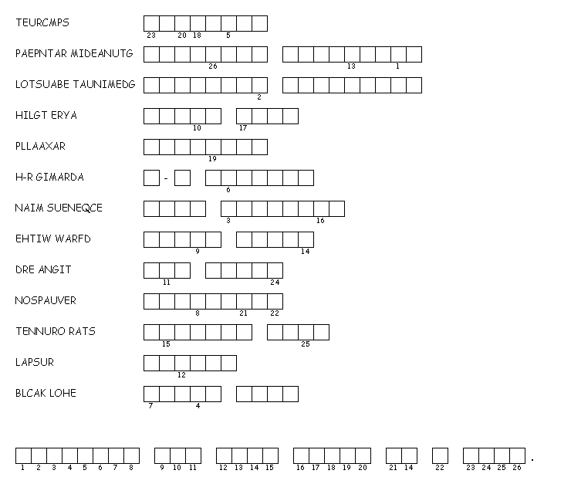

Test Prep
16) Which of the following is a chemical property?
A) density
B) flammability
C) melting point
D) color

17) Which of the following is true about elements?
A) They are impure substances.
B) They cannot be classified by their properties alone.
C) They cannot be broken down into simpler substances.
D) They have more than one kind of particle.

18) Which of the following is NOT true of compounds?
A) They contain two or more elements.
B) They form after a physical change.
C) They have their own physical properties.
D) They do not form randomly.

19) What can be said about the properties of a compound?
A) They are different from the properties of the elements that form the compound.
B) They are identical to the properties of the elements that form the compound.
C) They are not unique.
D) They are formed after a physical reaction.

20) What is a pure substance made of two or more elements that are chemically combined
called?
A) a solution
B) a compound
C) a mixture
D) an element

